
D.K.T.E. Society’s Textile and Engineering Institute, Ichalkaranji.
(An Empowered Autonomous Institute, Affiliated to Shivaji University, Kolhapur)
Department of Computer Science & Engineering
2026-2027

AI Tools for Software Development Project Report On
LOANFLOW: Smart Loan Application Tracking and Management System

Under The Guidance Of
Prof.(Dr).P.M.Gavali
Submitted By:
- 23UCS123 Prafull Prataprao Shinde

Dr. P. M. Gavali Prof. (Dr.) D.V.Kodavade
Project Guide Head of Department

External Examiner
INDEX

1 | Introduction
 | 1.1 Project Overview and Problem Statement
 | 1.2 Existing Project and Limitations
 | 1.3 Objectives
 | 1.4 Proposed AI-Assisted Approach
2 | Requirement Analysis
 | 2.1 Functional and Non-Functional Requirements
 | 2.2 User Stories and Acceptance Criteria
 | 2.3 Prompts, AI Outputs and Refinement
3 | System Design
 | 3.1 System Architecture and Module Design
 | 3.2 User Interface Design / Wireframes
 | 3.3 Design Prompts, AI Outputs and Final Design
4 | Coding and Implementation
 | 4.1 Development Environment and Technology Stack
 | 4.2 AI-Assisted Code Generation
 | 4.3 Debugging, Refactoring and Code Optimization
 | 4.4 Coding Prompts, Generated Code and Manual Modifications
5 | Testing
 | 5.1 Testing Strategy and Test Plan
 | 5.2 AI-Generated Test Cases
 | 5.3 Unit, Integration and System Testing
 | 5.4 Defect Identification and AI-Assisted Debugging
 | 5.5 Testing Prompts and Actual Results
6 | Deployment and Documentation
 | 6.1 Deployment and Execution Procedure
 | 6.2 Deployment Prompts and Configuration
 | 6.3 User Manual and Technical Documentation
7 | References
8 | Appendices  - Appendix A: Complete Prompt Dictionary and Prompt History  - Appendix B: AI Tool Usage Log  - Appendix C: Important Source Code and Screenshots  - Appendix D: Test Cases and Execution Evidence
1. INTRODUCTION

1.1 Project Overview and Problem Statement

1.1.1 Project Overview
LOANFLOW is a cloud-native, end-to-end Loan Application Lifecycle Management and Automated Underwriting Platform designed for retail and commercial lending institutions, Non-Banking Financial Companies (NBFCs), and digital fintech lenders. Built using modern web technologies, including JavaScript (ES6+), React 18, Express.js, Node.js, and MongoDB Atlas, the system manages the complete loan origination pipeline through a unified interface.
Loan Processing Workflow:
Lead/Customer Enquiry → Application Origination → Document Submission → Verification → Eligibility Engine → Credit Appraisal → Sanction Issuance → Fund Disbursement
LOANFLOW incorporates a rigid 9-stage finite state machine, dynamically configurable credit policy engines, dual-control credit governance (Loan Officer appraisal followed by independent Branch Manager approval), automated reducing-balance amortization calculations, structured document verification workflows, and an immutable audit trail.

1.1.2 Problem Statement
In traditional banking and conventional lending environments, the loan origination and underwriting process suffers from systemic friction, human error, lack of transparency, and operational bottlenecks.
1. Fragmented Lead Intake and Disjointed Tracking: Customer loan inquiries arrive through disconnected channels such as unencrypted email threads, manual paper slips, WhatsApp messages, or static web forms. Leads frequently remain unattended, and there is no structured mechanism to convert an informal inquiry into a formal loan dossier without duplicate data entry.
2. Chaotic and Insecure Document Verification: Loan applicants submit identification proofs (Aadhaar, Passport, PAN), income statements, and bank records through unverified channels. Loan verification officers lack a unified workspace to view, inspect, approve, or reject individual documents with actionable feedback, resulting in prolonged turnaround times (TAT).
3. Subjective and Error-Prone Credit Eligibility Calculations: Traditional loan officers manually calculate financial feasibility using spreadsheets or ad hoc calculators. Manual calculations of Debt-to-Income (DTI) ratios and monthly reducing-balance Equated Monthly Installments (EMI) frequently introduce errors and may violate institutional credit policies.
EMI Formula:
$$\text{EMI}=\frac{P×r×{\left(1+r\right)}^{n}}{{\left(1+r\right)}^{n}-1}$$

Debt-to-Income (DTI) Formula:

$$\text{DTI}=\frac{\text{Existing Monthly Obligations}+\text{Proposed EMI}}{\text{Gross Monthly Income}}×100\%$$

Where:
- P = Principal loan amount
- r = Monthly interest rate
- n = Total number of monthly installments
4. Absence of Strict Stage-Gate Governance: Legacy platforms often allow arbitrary status changes. For example, an application could mistakenly be approved without completing document verification or satisfying credit eligibility rules.
5. Lack of Dual-Control Separation of Powers: Smaller financial institutions frequently permit single-point approvals, increasing credit risk, fraudulent approvals, and conflicts of interest. There is no automated segregation between the loan assessor (Loan Officer) and the sanctioning authority (Credit Manager or Branch Manager).
6. Opaque Customer Experience: Borrowers often lack information regarding application progress, document rejection reasons, or counter-offer terms, leading to increased application abandonment and customer dissatisfaction.
7. Incomplete Audit Trails: Regulatory compliance requires a reliable record of every stage transition, actor identity, timestamp, and justification. Traditional spreadsheet-based systems rarely enforce an append-only historical record.

1.2 Existing Project and Limitations

1.2.1 Existing Systems in the Market
Existing loan processing systems in the financial services sector generally fall into three categories:
1. Legacy Core Banking and Semi-Manual ERPs: Legacy banking frameworks, including mainframe-based modules and monolithic ERP suites, often have steep learning curves, cluttered interfaces, limited customization capabilities, and slow deployment cycles.
2. Disconnected Spreadsheets and Manual Workflows: These are common among smaller NBFCs, credit societies, and micro-lending agencies, where Excel sheets, physical paper files, and email attachments are used to manage loan applications.
3. Heavyweight Enterprise Loan Origination Systems (LOS): Enterprise platforms, such as Temenos, Finacle, and Salesforce Financial Services Cloud, can be expensive for mid-sized NBFCs, require extensive system integration, and include complex features that smaller institutions may not need.

1.2.2 Key Limitations of Existing Systems

Dimension | Legacy / Manual Systems | Enterprise Commercial Platforms | LOANFLOW (Proposed System)
Architectural Agility | Monolithic, paper-dependent, spreadsheet-driven systems. | Complex enterprise architecture with heavy infrastructure requirements. | Lightweight MERN architecture with cloud-native REST APIs.
State Machine Governance | Manual updates that may skip stages. | Complex proprietary rule languages requiring specialized consultants. | Deterministic 9-stage finite state machine with strict programmatic stage gates.
Document Processing | Physical photocopies or unencrypted email attachments without version control. | Third-party document suites with potentially complex workflows. | Multi-format PDF, PNG, and JPG document workspace with individual file statuses and inline viewing.
Credit Assessment | Manual calculations prone to arithmetic errors and subjective bias. | Opaque risk-scoring models with rigid parameters. | Transparent, configurable rule engine with reducing-balance EMI calculations and product-specific DTI limits.
Governance and Segregation | Weak dual-control mechanisms; single-officer approvals are common. | Complex approval hierarchies that may cause delays. | Dual-control model: Loan Officer appraisal followed by Branch Manager approval.
Auditability and Traceability | Fragmented logs that may be overwritten or tampered with. | Costly audit storage modules. | Append-only ApplicationStatusHistory recording actor ID, role, timestamp, and remarks.
User Experience (Multi-Role) | Cluttered interfaces with high training requirements. | Separate portals requiring different licenses and logins. | Role-Based Access Control (RBAC) with dedicated portals for Customer, Loan Officer, Manager, and Admin, plus a one-click evaluation persona switcher.

1.3 Objectives
The primary engineering and functional objectives of the LOANFLOW project are categorized into Core Functional Objectives, Technical and Architectural Objectives, and AI-Assisted Development Objectives.

1.3.1 Core Functional and Business Objectives
1. Lead Intake and Sequence Generation: Design an automated intake engine that generates human-readable sequence numbers, such as ENQ-2026-XXXX and LOAN-2026-XXXX, to facilitate one-click conversion from an enquiry to an active loan application.
2. Controlled 9-Stage Finite State Machine: Implement a deterministic loan lifecycle with the following stages:
DRAFT → DOCUMENT_PENDING → UNDER_REVIEW → ELIGIBILITY_CHECKED → RECOMMENDED → APPROVED/REJECTED → SANCTIONED → DISBURSEMENT_PENDING → DISBURSED
Ensure that unauthorized or stage-skipping transitions are prevented at the API level.
3. Multi-Category Document Repository with Inline Viewer: Provide a structured upload and verification pipeline supporting identity, address, income, bank statement, and employment documents. Implement MIME-type filtering, file size restrictions of up to 5 MB, inline browser previews, and a targeted re-upload process for rejected documents.
4. Deterministic Quantitative Eligibility Engine: Implement automated reducing-balance EMI calculations and product-specific dynamic DTI compliance checks, such as:
- Personal Loan: 50%
- Home Loan: 55%
- Vehicle Loan: 45%
5. Dual-Control Credit Governance: Enforce a separation of responsibilities between the Loan Officer, who prepares the appraisal dossier, and the Branch Manager, who has final authority to sanction or reject the application with mandatory justification.
6. Executive Sanction and Fund Disbursement: Automatically generate structured sanction records, such as SANC-2026-XXXX, and disbursement transaction records, such as DISB-2026-XXXX, with UTR tracking. Ensure that disbursements do not exceed sanctioned credit limits.
7. Immutable Chronological Audit Trail: Maintain a reliable historical record of every status change, timestamp, acting user ID, role, and accompanying comments for compliance and traceability.

1.3.2 Technical and Architectural Objectives
1. Modern MERN Architecture Using Pure JavaScript: Develop the solution using React 18+ with Vite for the frontend, Node.js and Express.js for the backend, and MongoDB Atlas with Mongoose ODM. Follow clean ES6+ JavaScript practices without TypeScript.
2. Responsive Fintech SaaS User Interface: Build an intuitive, high-contrast interface following modern fintech SaaS design principles using Tailwind CSS, Lucide icons, and Recharts for interactive analytics.
3. Robust Security and Role-Based Access Control: Secure endpoints using JSON Web Tokens (JWT), HTTP security headers through Helmet, Bcrypt password hashing with 10 salt rounds, and strict Cross-Origin Resource Sharing (CORS) whitelisting
.
1.3.3 AI-Assisted Development Objectives
1. AI-Driven System Lifecycle: Execute the software engineering lifecycle, including requirements engineering, architecture design, database schema generation, frontend component development, backend API development, test writing, and bug resolution, using generative AI and agentic coding workflows.
2. Prompt-Driven Architecture and Refinement: Establish a structured prompt-engineering workflow that converts high-level domain requirements into executable specifications, reusable boilerplate, and business logic.
3. AI-Assisted Defect Identification and Optimization: Use AI tools to identify root causes of system defects, including port binding conflicts, division-by-zero errors in amortization calculations, and authentication failures during document preview, and implement verified solutions.

1.4 Proposed AI-Assisted Approach

The development of LOANFLOW followed an AI-Assisted Software Development Paradigm, using an iterative workflow:
Prompt → Synthesis → Review → AI Refinement → Verification
The workflow was powered by Antigravity (Google DeepMind), supporting the development and refinement of the system through structured prompts and iterative verification.

1.4.1 Step-by-Step AI-Assisted Workflow
1. AI-Driven Requirements Engineering and Specification Synthesis
- Structured system prompts were provided to the AI, incorporating banking domain requirements, fintech best practices, and the required 9-stage loan lifecycle.
- The AI generated the Business Requirements Document (BRD), finite state transition matrix, and MongoDB entity-relationship definitions.
2. AI-Powered Architecture and Database Schema Synthesis
- Prompts specified the core entities: User, LoanProduct, LoanEnquiry, LoanApplication, ApplicationDocument, ApplicationStatusHistory, and Notification.
- The AI generated Mongoose schemas with indexed reference fields, pre-save status hooks, validation constraints, and role-based access models.
3. Autonomous Component and API Generation
- Backend: The AI generated Express.js routes, controllers, middleware, and business logic modules using ES Modules (import/export). It implemented reducing-balance EMI calculations and dynamic DTI checks without relying on external black-box libraries.
- Frontend: Prompts guided the creation of modular React components, custom hooks, and Tailwind CSS layouts. The AI generated role-specific dashboards for Customers, Loan Officers, Managers, and Administrators, including a one-click persona switcher for academic evaluation.
4. AI-Assisted Code Refactoring and Edge-Case Mitigation
During implementation, several real-world edge cases were analyzed and addressed through AI-assisted debugging:
- Amortization Edge Cases: The AI identified potential NaN and division-by-zero errors when applicants entered zero interest rates or zero loan tenure. Mathematical safeguards were added to the calculateEmi function.
- Document Preview Streaming: The AI diagnosed authentication failures (401 Unauthorized) when opening stored documents in new browser tabs. The document delivery workflow was refactored to support secure inline previews across different candidate directories.
- Environment Port Collisions: The AI analyzed local process sockets using PowerShell commands and helped resolve port conflicts involving Node.js and Vite.
5. Automated Test Generation and AI Verification
- The AI generated automated test suites (test:api) for core domain logic, including reducing-balance amortization calculations, DTI boundary conditions, and stage-gate transition restrictions.
- Full-stack compilation was validated using npm run build, transforming more than 2,490 client modules into JavaScript bundles with zero build-time warnings.
6. Documentation and Knowledge Base Compilation
- The AI generated technical manuals, database documentation, API reference guides, and live demonstration scripts, creating a traceable software engineering development record.

2. REQUIREMENT ANALYSIS

2.1 Functional and Non-Functional Requirements

2.1.1 Functional Requirements (FR)
The functional requirements for LOANFLOW define the specific behaviors, operations, and business rules enforced by the application across its 9 lifecycle stages and 4 user personas: CUSTOMER, LOAN_OFFICER, MANAGER, and ADMIN.
LOANFLOW System Modules
1. Identity and Role-Based Access Control (RBAC)
- JWT authentication and Bcrypt password hashing (10 rounds).
- Four role-specific workspaces.
2. Lead and Enquiry Intake
- Automatic enquiry code generation (ENQ-2026-XXXX).
- One-click lead conversion.
3. Application Origination
- Automatic application code generation (LOAN-2026-XXXX).
- Demographic and debt information collection.
4. Document Workbench
- Five mandatory proof categories.
- Inline document preview and verification.
5. Quantitative Eligibility Engine
- Reducing-balance EMI calculations.
- Dynamic, product-specific DTI limits.
6. Dual-Control Underwriting
- Loan Officer appraisal dossier.
- Manager sanction approval.
7. Sanction Management
- Sanction code generation (SANC-2026-XXXX).
- Counter-offer APR and tenure management.
8. Fund Disbursement
- UTR-based transaction tracking.
- Disbursed amount must not exceed the sanctioned amount.
9. Audit and Notifications
- Append-only audit trail.
- In-app notification center.

FR-1: Authentication and Role-Based Access Control (RBAC)
- FR-1.1: The system shall authenticate users via JSON Web Tokens (JWT), stored securely and transmitted through HTTP Authorization: Bearer <token> headers.
- FR-1.2: The system shall enforce strict role validation across four distinct roles:
- CUSTOMER: Can create enquiries, manage owned applications, upload or re-upload documents, view loan status, and accept sanctions.
- LOAN_OFFICER: Can triage leads, convert enquiries to applications, verify or reject uploaded documents with mandatory feedback, trigger eligibility checks, and compile underwriting appraisal recommendations.
- MANAGER: Holds executive credit authority to sanction or reject applications, modify sanction amounts and tenures, and execute fund disbursements.
- ADMIN: Manages platform configuration, adjusts loan product terms and DTI thresholds, provisions user accounts, and monitors system throughput analytics.
- FR-1.3: The platform shall provide a one-click evaluation persona switcher in the navigation bar to enable rapid testing across all roles without requiring manual logout and login cycles.

FR-2: Lead and Enquiry Management
- FR-2.1: Prospective borrowers shall be able to submit loan enquiries with product type, requested loan amount, employment details, and gross monthly income.
- FR-2.2: The system shall automatically assign a sequential identifier formatted as ENQ-2026-XXXX.
- FR-2.3: Loan Officers shall be able to triage new enquiries, record contact attempts (CONTACTED), and convert qualified enquiries into formal loan applications with a single click (CONVERTED), automatically provisioning the customer user account.

FR-3: Application Origination and Profiling
- FR-3.1: Formal loan applications shall be assigned a unique sequential identifier formatted as LOAN-2026-XXXX.
- FR-3.2: The application shall capture comprehensive demographic and financial information, including:
- Full Name
- Date of Birth
- PAN
- Residential Address
- Employer Name
- Employment Type
- Years in Service
- Gross Monthly Income
- Existing Monthly Debt Obligations
- FR-3.3: Newly generated applications shall enter the DOCUMENT_PENDING stage and automatically populate a mandatory document checklist.

FR-4: Document Upload and Verification Workbench
- FR-4.1: The system shall enforce mandatory collection of five standardized document proofs:
- IDENTITY_PROOF: Aadhaar, Passport, PAN, or Voter ID.
- ADDRESS_PROOF: Utility Bill, Passport, or Rental Agreement.
- INCOME_PROOF: Salary Slips, ITR, or Form 16.
- BANK_STATEMENT: Bank statements covering the last six months.
- EMPLOYMENT_PROOF: Employee ID or Appointment Letter.
- FR-4.2: The upload pipeline shall validate file types (.pdf, .jpg, .jpeg, .png) and enforce an individual file size limit of 5 MB (5,242,880 bytes).
- FR-4.3: Loan Officers shall have access to an inline verification viewer that supports two actions for each file:
- Verify: Transitions the document state to VERIFIED.
- Reject: Requires a mandatory justification comment of at least five characters. The application transitions to ADDITIONAL_DOCUMENTS_REQUIRED.
- FR-4.4: Customers shall be permitted to re-upload only rejected or pending documents without overwriting previously verified proofs.

FR-5: Quantitative Financial Eligibility Engine
- FR-5.1: The system shall calculate monthly installments using the reducing-balance amortization formula:
$$\text{EMI}=\frac{P×r×{\left(1+r\right)}^{n}}{{\left(1+r\right)}^{n}-1}$$Where:
- P = Principal loan amount
- r = Monthly interest rate = APR / (12 × 100)
- n = Loan tenure in months
- FR-5.2: The engine shall calculate the applicant's Debt-to-Income (DTI) ratio using the formula:
$$\text{DTI}=\frac{\text{Existing Monthly Obligations}+\text{Proposed EMI}}{\text{Gross Monthly Income}}×100\%$$
- FR-5.3: The engine shall evaluate four parameterized criteria against product configurations:
- Monthly Income ≥ Product Minimum Income.
- Product Minimum Amount ≤ Requested Amount ≤ Product Maximum Amount.
- Product Minimum Tenure ≤ Requested Tenure ≤ Product Maximum Tenure.
- DTI ≤ Product Maximum DTI Percentage.
Example DTI limits:
- Personal Loan: 50%.
- Home Loan: 55%.
- Vehicle Loan: 45%.
- FR-5.4: The system shall store rule assessment results immutably as structured JSON objects.

FR-6: Dual-Control Underwriting and Credit Appraisal
- FR-6.1: An application cannot transition to ELIGIBILITY_CHECK until 100% of the required documents have been marked VERIFIED.
- FR-6.2: A Loan Officer cannot forward an application for MANAGER_APPROVAL without recording formal appraisal notes and selecting a recommendation: RECOMMEND_APPROVAL or RECOMMEND_REJECTION.
- FR-6.3: A Branch Manager cannot approve an application without reviewing the Loan Officer's appraisal dossier and eligibility results. The Manager can approve the requested amount or issue a counter-offer with an amended sanctioned amount and tenure.

FR-7: Sanction Generation and Fund Disbursement
- FR-7.1: Upon executive approval, the system shall generate a formal sanction decree code (SANC-2026-XXXX) containing the approved principal, tenure, APR, and calculated EMI.
- FR-7.2: The Manager or disbursement desk shall execute fund transfers by submitting the payment method (NEFT, RTGS, or IMPS), bank transaction reference or UTR number, and disbursement date. A disbursement record shall be generated using the format DISB-2026-XXXX.
- FR-7.3: The system shall enforce the following constraint:
Disbursed Amount ≤ Sanctioned Amount.

FR-8: Audit Logging and In-App Alerts
- FR-8.1: Every stage transition shall append an unalterable record to ApplicationStatusHistory, capturing the old status, new status, actor ID, actor role, timestamp, and transition remarks.
- FR-8.2: The system shall dispatch in-app notifications whenever an application status changes, documents are rejected, or funds are disbursed.

2.1.2 Non-Functional Requirements (NFR)
NFR-1: Performance and Responsiveness
- NFR-1.1 — API Response Time: All standard database query and status update endpoints shall respond in less than 200 milliseconds under normal load.
- NFR-1.2 — Eligibility Engine Execution: Mathematical amortization and rule evaluations shall execute in under 50 milliseconds synchronously.
- NFR-1.3 — Client Load Time: The single-page application (SPA) shall achieve an interactive paint time of less than 1.5 seconds on broadband connections.
NFR-2: Security and Data Integrity
- NFR-2.1 — Password Security: User credentials shall be salted and hashed using Bcrypt with a work factor of 10 rounds before persistent storage.
- NFR-2.2 — Transport Security: All API endpoints shall enforce HTTP security headers through Helmet middleware and restrict unauthorized cross-origin requests using strict CORS origins.
- NFR-2.3 — File Upload Quarantining: Files shall be sanitized against extension tampering and stored in application-partitioned directories using the path uploads/documents/{applicationId}/.
- NFR-2.4 — Stage-Gate Defense: Direct manual status manipulations that bypass prerequisite stages shall be rejected with HTTP 422 (Unprocessable Entity).
NFR-3: Reliability and Auditability
- NFR-3.1 — Append-Only Audit Log: Historical audit entries shall not support UPDATE or DELETE API endpoints, ensuring non-repudiation for financial compliance.
- NFR-3.2 — Database Uptime: The cloud database instance (MongoDB Atlas M0/Serverless) shall provide high availability with automatic replica failover.
NFR-4: Usability and Accessibility
- NFR-4.1 — Modern Fintech Aesthetic: The interface shall follow professional financial SaaS design standards using a deep navy palette (#0F172A), action blue accents (#2563EB), clear status badges, and Recharts analytics.
- NFR-4.2 — Responsive Layout: The user interface shall adapt to desktop, tablet, and mobile displays without loss of operational functionality.
NFR-5: Technical and Maintainability Standards
- NFR-5.1 — Pure JavaScript Mandate: All client and server components shall use modern JavaScript (ES6+) exclusively, with zero TypeScript files (.ts, .tsx) or tsconfig.json files.
- NFR-5.2 — Modular Architecture: The codebase shall enforce a clean separation of concerns through the following structure:
Route → Controller → Service/Engine → Model.

2.2 User Stories and Acceptance Criteria
User Story 1: Lead Inquiry Submission and Conversion
As a prospective borrower or Loan Officer,
I want to submit or qualify an initial loan enquiry and convert it into a formal loan application with one click,
So that customer onboarding is streamlined without redundant data entry.
Acceptance Criteria (Gherkin)
Scenario 1: Customer submits a loan inquiry
- Given a prospective applicant visits the loan portal.
- When they submit their name, email, phone number, requested amount, product, and monthly income.
- Then the system creates an enquiry record with identifier ENQ-2026-XXXX and status NEW.
Scenario 2: Officer converts a qualified lead
- Given an enquiry with status NEW or CONTACTED.
- When the Loan Officer clicks "Convert to Application".
- Then the enquiry transitions to CONVERTED, a new User account is provisioned if one does not already exist, a LoanApplication with code LOAN-2026-XXXX is generated in the DOCUMENT_PENDING state, and an audit entry is recorded.

User Story 2: Mandatory Document Upload and Inspection Workbench
As a Loan Officer,
I want to view, verify, or reject each submitted document with detailed feedback,
So that only compliant legal and financial proofs advance to the underwriting stage.
Acceptance Criteria (Gherkin)
Scenario 1: Successful verification of proofs
- Given an application with uploaded proofs in DOCUMENT_VERIFICATION status.
- When the Officer inspects a document in the inline modal viewer and clicks "Verify".
- Then the document status updates to VERIFIED, and the file is permanently locked against customer modification.
Scenario 2: Rejection with actionable justification
- Given an unreadable or deficient document.
- When the Officer clicks "Reject" without providing feedback.
- Then the system displays a validation error requiring at least five characters of feedback.
- When the Officer enters a valid explanation, such as "Page 3 of bank statement missing".
- Then the document is marked REJECTED, the application transitions to ADDITIONAL_DOCUMENTS_REQUIRED, and an in-app notification containing the feedback is sent to the customer.

User Story 3: Deterministic Financial Eligibility Assessment
As a Credit Risk Assessor or System Engine,
I want to automatically calculate the reducing-balance EMI and Debt-to-Income (DTI) ratio against product limits,
So that human arithmetic bias is eliminated and institutional credit policies are strictly enforced.
Acceptance Criteria (Gherkin)
Scenario 1: Applicant meets all credit criteria
- Given an applicant with a monthly income of ₹55,000 and existing obligations of ₹5,000, applying for a ₹4,00,000 Personal Loan at 11.5% APR for 36 months.
- When the Eligibility Engine runs.
- Then it computes EMI = ₹13,190, Total Obligations = ₹18,190, and DTI = 33.07%.
- And verifies that 33.07% ≤ 50.0% (Personal Loan limit), marking the applicant ELIGIBLE with all four rule checks passed.
Scenario 2: Vehicle Loan policy ceiling rejection
- Given an applicant whose total obligations result in a 48% DTI while applying for a Vehicle Loan.
- When the engine checks the configured product rule (maxDtiPercent = 45%).
- Then the DTI_THRESHOLD rule evaluates to passed: false, and the assessment returns NOT_ELIGIBLE.

User Story 4: Dual-Control Manager Sanction and Disbursement
As a Branch Credit Manager,
I want to review the complete underwriting dossier and authorize or amend the final sanction terms,
So that credit disbursements are secured through the separation of duties.
Acceptance Criteria (Gherkin)
Scenario 1: Enforcing stage gates before sanction
- Given an application where one or more documents remain in PENDING or REJECTED status.
- When the Manager attempts to access the sanction approval form.
- Then the approval button is disabled, and the backend API rejects the request with HTTP 422.
Scenario 2: Successful sanction decree issuance
- Given an application in MANAGER_APPROVAL status with an Officer's approval recommendation.
- When the Manager confirms the sanction amount of ₹4,00,000 at 11.5% APR for 36 months.
- Then the application status updates to APPROVED, creates a Sanction record with identifier SANC-2026-XXXX, and moves the file to DISBURSEMENT_PENDING.
Scenario 3: Disbursement validation ceiling
- Given a sanctioned loan of ₹4,00,000.
- When the disbursement Officer enters a disbursement amount of ₹4,50,000.
- Then the system blocks the transaction with the error: "Disbursement amount cannot exceed sanctioned amount".
- When a valid amount of ₹4,00,000 and a valid UTR number are submitted.
- Then the application transitions to DISBURSED, and the transaction is permanently recorded.

2.3 Prompts, AI Outputs and Refinement
Because LOANFLOW was developed using an AI-assisted software development model, requirements engineering was conducted iteratively through structured prompt engineering with Antigravity (Google DeepMind). This section documents the core requirements-engineering prompts, initial AI outputs, and subsequent refinements.

2.3.1 Iteration 1: Domain Modeling and BRD Extraction
Prompt Provided to AI
"Act as a Principal Financial Systems Architect. I need a comprehensive Business Requirements Document for LOANFLOW, an end-to-end loan application tracker and underwriting platform. The system must support retail lending across four user roles: Customer, Loan Officer, Branch Manager, and Admin. Outline the operational lifecycle from initial customer inquiry to final fund disbursement. Detail the required functional modules, state transitions, and compliance considerations. Output the specification in structured Markdown."

Raw AI Output
The AI generated a standard six-stage lifecycle (New → Documents → Underwriting → Approved → Disbursed) with generic file uploads and standard user roles. It recommended a flat-interest calculation formula for simplicity:
I = P × R × T
It also proposed a static 50% Debt-to-Income ceiling across all loan types.

Critical Evaluation and Refinement
- Flaw Identified: Real-world retail installment loans commonly use reducing-balance amortization rather than flat-rate simple interest, where interest decreases as the outstanding principal is repaid.
- Flaw Identified: A generic six-stage lifecycle lacked stage gates for exception handling, such as document rejection and re-upload, and did not enforce formal dual-control segregation between Officers and Managers.
- Refinement Applied: The AI was instructed to expand the lifecycle into a rigid 9-stage finite state machine, incorporate reducing-balance amortization, and make product DTI ceilings (maxDtiPercent) configurable attributes of the LoanProduct schema:
  - Personal Loan: 50%.
  - Home Loan: 55%.
  - Vehicle Loan: 45%.

2.3.2 Iteration 2: Stage-Gate State Machine and Dual-Control Rule Design
Prompt Provided to AI
"Refine the LOANFLOW business rules to enforce a strict stage-gate state machine and a dual-control credit governance model. Specify the exact mathematical conditions under which an application can transition between stages: DOCUMENT_PENDING, DOCUMENT_VERIFICATION, ADDITIONAL_DOCUMENTS_REQUIRED, ELIGIBILITY_CHECK, OFFICER_REVIEW, MANAGER_APPROVAL, APPROVED, SANCTIONED, DISBURSEMENT_PENDING, and DISBURSED. Explicitly define what role is authorized for each transition, what triggers it, and the mandatory pre-conditions."

Raw AI Output
The AI provided a transition table mapping actions to states and specified that LOAN_OFFICER could approve loans under ₹5,00,000, while MANAGER would approve loans above ₹5,00,000. It also generated a basic document status enumeration: PENDING, APPROVED, and REJECTED.

Critical Evaluation and Refinement
- Flaw Identified: Allowing Loan Officers to approve loans under ₹5,00,000 violates the core dual-control banking principle of separating assessment from sanction authority.
- Flaw Identified: The document upload process allowed customers to upload new files at any time, potentially invalidating an ongoing underwriting review.
- Refinement Applied: The AI was instructed to enforce that only the Branch Manager holds credit approval authority. The Loan Officer's responsibilities were restricted to compiling the appraisal dossier and making a non-binding recommendation (RECOMMEND_APPROVAL or RECOMMEND_REJECTION). Documents were also locked once marked VERIFIED.

2.3.3 Iteration 3: Technology Constraints and Non-Functional Specifications
Prompt Provided to AI
"Formulate the technical and non-functional requirements for LOANFLOW. The architectural constraint is strict: use pure JavaScript (ES6+) across the entire stack—Node.js, Express.js, React 18 (Vite), Tailwind CSS, and MongoDB Atlas via Mongoose. Absolutely zero TypeScript (.ts/.tsx) or tsconfig files are permitted. Define security headers, password hashing rounds, file quarantine policies, and audit logging specifications."

Raw AI Output
The AI generated a complete technical stack specification that included Bcrypt with 10 salt rounds, Helmet security headers, CORS configuration, Multer storage configuration with 5 MB upload limits, and an append-only ApplicationStatusHistory schema. It also generated a Gherkin-formatted test matrix covering user stories across all four roles
.
Critical Evaluation and Refinement
- Refinement Applied: The architecture was finalized using pure JavaScript ES Modules (import/export). A one-click evaluation persona switcher was added to the navigation bar to simplify evaluation of the four distinct user workflows. This completed the formal requirements analysis.

3. System Design

3.1 System Architecture and Module Design
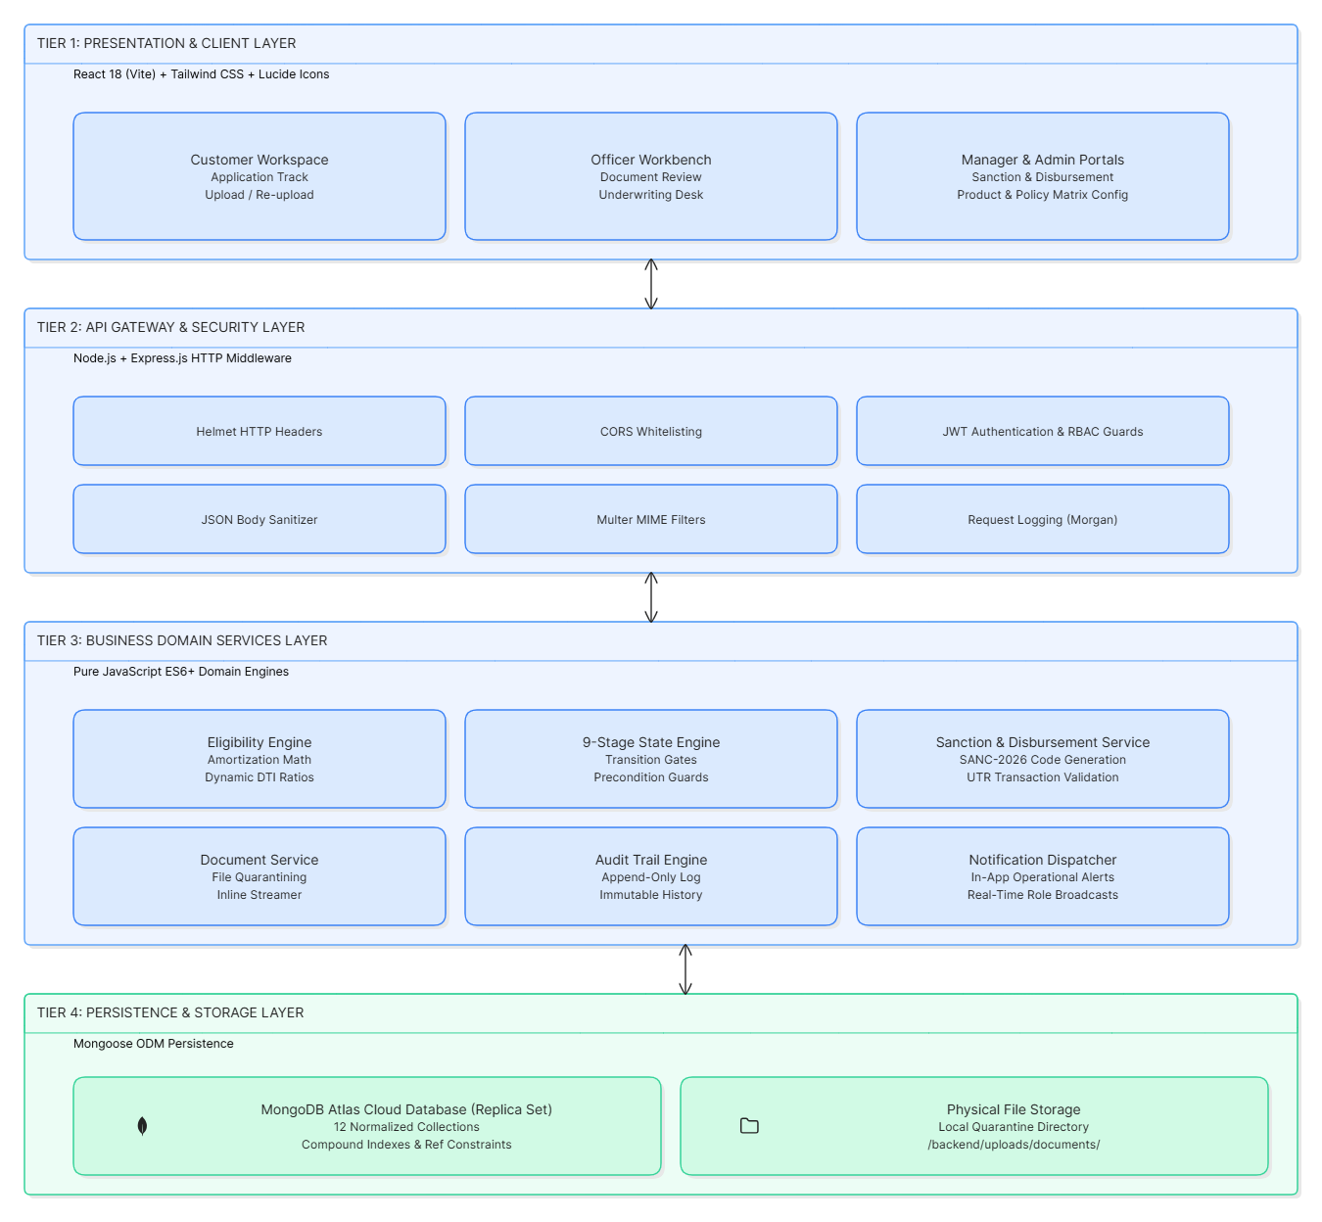
3.1.1 High-Level Tiered Architecture
LOANFLOW follows a modern, decoupled 4-Tier Web Architecture built with pure JavaScript (ES6+), optimized for cloud deployment and high-throughput financial operations:

3.1.2 Detailed Module Design
1. Identity & RBAC Service Module
- Purpose: Manages user authentication, session hydration, and role authorizations.
- Components: authController.js, authMiddleware.js, User.js, Customer.js.
- Security: Issues signed HMAC SHA-256 JWT tokens containing id, role, name, and email with a 7-day expiration. Passwords are irreversibly hashed using Bcrypt with 10 salt rounds. Protected API endpoints invoke requireAuth followed by requireRole(['LOAN_OFFICER', 'MANAGER', ...]).
2. Lead Intake & Conversion Module
- Purpose: Captures public inquiries and transforms qualified prospects into active loan files.
- Components: enquiryController.js, enquiryRoutes.js, LoanEnquiry.js.
- Logic: Automatically increments human-readable ticket numbers (ENQ-2026-XXXX). The conversion endpoint creates both a customer account record and a formal loan application (LOAN-2026-XXXX) within a single transactional sequence.
3. 9-Stage State Machine & Application Lifecycle Module
- Purpose: Enforces deterministic stage transitions and blocks non-linear stage overrides.
- Components: applicationController.js, LoanApplication.js.
- Transition Gates:
DRAFT → DOCUMENT_PENDING → DOCUMENT_VERIFICATION → ADDITIONAL_DOCUMENTS_REQUIRED → ELIGIBILITY_CHECK → OFFICER_REVIEW → MANAGER_APPROVAL → APPROVED/SANCTIONED → DISBURSEMENT_PENDING → DISBURSED
4. Document Management & Inline Streaming Module
- Purpose: Handles document uploads, storage segregation, and inline browser previews.
- Components: documentController.js, uploadMiddleware.js, ApplicationDocument.js.
- Storage Strategy: Stores uploaded files on a partitioned physical directory path (uploads/documents/{applicationId}/).
- Inline Streaming Engine: Documents are served through GET /api/documents/:id/file with dynamic Content-Type and Content-Disposition: inline headers, enabling instant PDF and image rendering inside browser tabs.
5. Quantitative Financial Eligibility Engine
- Purpose: Computes installment amortization and dynamically validates credit feasibility.
- Components: eligibilityEngine.js, eligibilityController.js, EligibilityAssessment.js.
- Amortization Logic:
$$\text{EMI}=\frac{P×r×{\left(1+r\right)}^{n}}{{\left(1+r\right)}^{n}-1}$$
Where:
- P= Principal loan amount
- r = $r=\frac{\text{APR}}{12×100}$= Monthly interest rate
- n = Loan tenure in months
- Configurable Policy Evaluation: Checks candidate income against product requirements and evaluates total debt against the product's configurable DTI ceiling (maxDtiPercent, e.g., 50% for Personal, 55% for Home, 45% for Vehicle).

6. Dual-Control Underwriting & Sanction Decree Module
- Purpose: Implements segregation of duties between credit assessment and credit sanction.
- Components: reviewController.js, approvalController.js, sanctionController.js, Sanction.js.
- Mechanism: The Loan Officer compiles appraisal dossier notes and submits a recommendation (RECOMMEND_APPROVAL or RECOMMEND_REJECTION). The Branch Manager reviews the dossier and issues a formal sanction record (SANC-2026-XXXX) with final approved principal, tenure, and APR.
7. Fund Disbursement & UTR Tracking Module
- Purpose: Processes fund payouts and tracks interbank transactions.
- Components: disbursementController.js, Disbursement.js.
- Ceiling Guard: Validates that $\text{Disbursed Amount}≤\text{Sanctioned Amount}$
Logs bank transfer type (NEFT, RTGS, IMPS), bank reference/UTR number, and execution timestamp before locking the loan into DISBURSED status.
8. Immutable Audit Trail & Notification Subsystem
- Purpose: Maintains regulatory non-repudiation and dispatches real-time alerts.
- Components: auditService.js, notificationService.js, ApplicationStatusHistory.js, Notification.js.
- Append-Only Policy: The status history collection exposes no PUT, PATCH, or DELETE endpoints, guaranteeing an unalterable forensic record of every action, actor ID, role, and comment.

3.1.3 Entity-Relationship Model (MongoDB Collections)

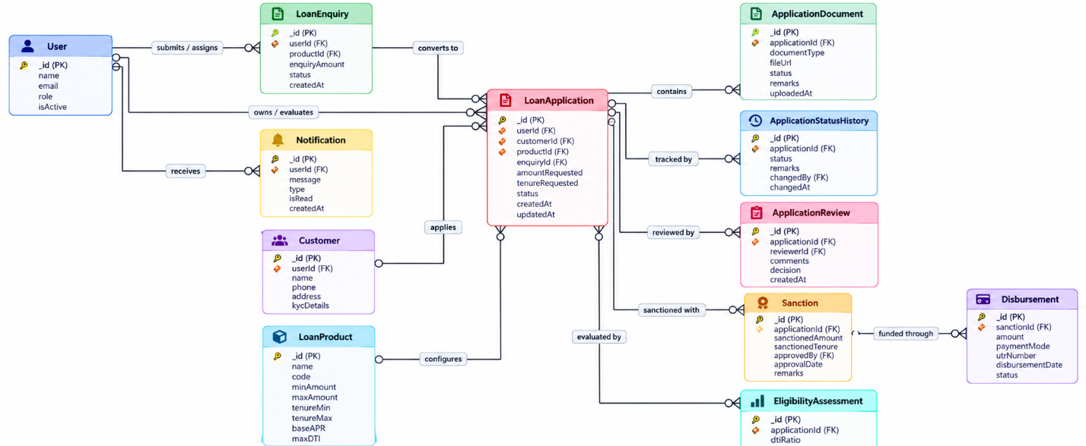

3.2 User Interface Design / Wireframes
The LOANFLOW frontend is designed to provide an intuitive, high-contrast fintech SaaS user experience. It follows a clean layout system, deep slate navy palette (#0F172A), action blue accents (#2563EB), emerald success badges (#10B981), amber warnings (#F59E0B), and clear typographic hierarchy.

3.2.1 Wireframe 1: Customer Loan Application Tracker & Document Workbench
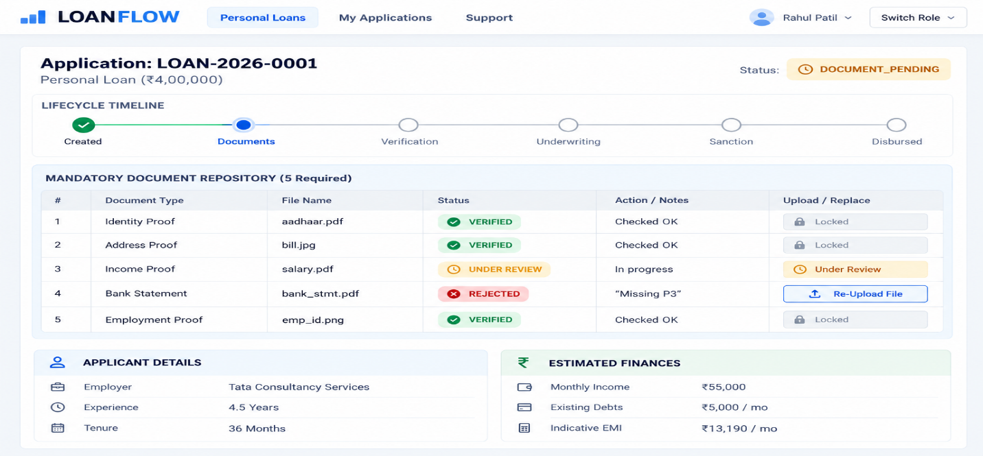

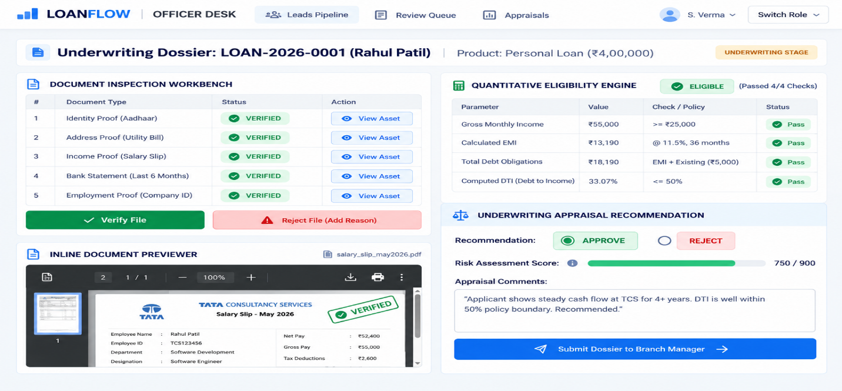
3.2.2 Wireframe 2: Loan Officer Document Verification & Underwriting Appraisal

3.2.3 Wireframe 3: Branch Manager Sanction Decree & Fund Disbursement
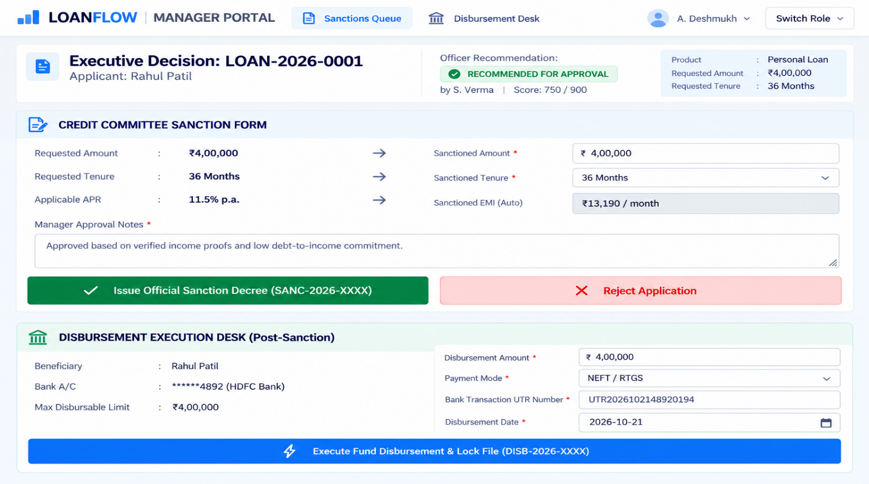

3.2.4 Wireframe 4: Admin Platform Governance & Dynamic Policy Configuration
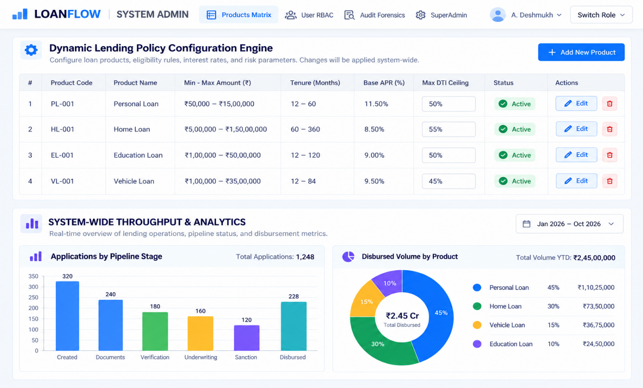

3.3 Design Prompts, AI Outputs and Final Design
Throughout the system design phase, generative and agentic AI prompt workflows translated business requirements into software architectures, database schemas, and interface wireframes.

3.3.1 Iteration 1: Multi-Tiered Architecture & Component Separation
Architectural Design Prompt:
"Design a decoupled 4-tier system architecture for LOANFLOW using Node.js, Express, React 18, and MongoDB Atlas. Ensure the design satisfies strict fintech compliance: stage-gate enforcement, JWT authentication, RBAC authorization, and append-only audit logging. Avoid monolith coupling by separating routes, controllers, domain services, and ODM schemas. Output a Mermaid system diagram and layer-by-layer specification."

Raw AI Output:
The AI generated a standard MVC architecture where controllers handled HTTP requests and directly invoked Mongoose queries. It also suggested using memory sessions instead of JWT and saving document files as Base64 strings directly in MongoDB.

Architectural Bottlenecks Discovered & Refinement:
- Bottleneck 1 (Database Bloat): Storing 5 MB PDF/image documents as Base64 strings directly in MongoDB rapidly degrades database throughput, exceeds document size limits (16 MB BSON cap), and consumes excessive RAM.
- Bottleneck 2 (Tight Coupling): Writing financial arithmetic directly inside Express route controllers prevented testability and reuse across endpoints.
- Refinement Implemented:
  - Refactored the file storage architecture to use Multer-managed local quarantined directory partitioning (uploads/documents/:applicationId/) while storing file metadata in MongoDB.
  - Decoupled business logic into independent domain engines (eligibilityEngine.js, auditService.js, notificationService.js).
  - Replaced session memory with stateless JWT authentication with Axios bearer interceptors.

3.3.2 Iteration 2: Normalized Database Schema & Mongoose Models
Schema Design Prompt:
"Generate normalized Mongoose schema definitions in ES6+ JavaScript for LOANFLOW. The schema must model 12 entities: User, Customer, LoanProduct, LoanEnquiry, LoanApplication, ApplicationDocument, EligibilityAssessment, ApplicationReview, Sanction, Disbursement, ApplicationStatusHistory, and Notification. Include compound indexes, enum constraints for the 9-stage state machine, and foreign key references. Formulate the schemas strictly in pure JavaScript without TypeScript."

Raw AI Output:
The AI generated individual Mongoose models with references and status enums. However, the LoanProduct schema hardcoded a 50% DTI limit across all products, and the ApplicationStatusHistory model included update triggers.

Critical Evaluation & Refinement:
- Refinement 1: Added dynamic maxDtiPercent to LoanProduct schema to allow individual loan categories (e.g., Vehicle Loans at 45%, Home Loans at 55%) to maintain distinct underwriting thresholds.
- Refinement 2: Enforced immutability on ApplicationStatusHistory by omitting any update middleware and marking historical timestamps as read-only.
- Refinement 3: Added human-readable sequence formatters (ENQ-2026-XXXX, LOAN-2026-XXXX, SANC-2026-XXXX, DISB-2026-XXXX) to facilitate physical and digital document referencing.

3.3.3 Iteration 3: User Interface Wireframing & Role Experience Design

UI Wireframe Design Prompt:
"Design responsive user interface wireframes and component layouts for LOANFLOW's 4 user roles using Tailwind CSS and shadcn/ui design conventions. The interfaces must include: (1) Customer loan tracker with stage progress and a document re-upload workbench; (2) Loan Officer split-view dossier with an inline document viewer and eligibility scorecards; (3) Branch Manager sanction counter-offer form and UTR disbursement modal; (4) Admin dynamic product configuration desk. Include an instant role-switching utility for demonstration purposes."

Raw AI Output:
The AI synthesized text-based wireframe layouts and React JSX component structures. It included tab-based navigation, modal dialogs, and progress steppers for application tracking.

Critical Evaluation & Refinement:
- Refinement 1: Added an inline document viewer modal supporting simultaneous document reading and verification actions, preventing underwriters from having to switch between browser tabs.
- Refinement 2: Integrated a prominent 1-Click Role Switcher dropdown in the top navbar (Customer: Rahul Patil, Officer: Sanjay Verma, Manager: Anjali Deshmukh, Admin: System Administrator) to allow evaluators to navigate between perspectives instantly without repetitive login flows.
- Refinement 3: Embedded real-time visual alerts (amber alert boxes for rejected documents with officer feedback) directly on the customer interface to provide actionable remediation steps.

4. CODING AND IMPLEMENTATION

4.1 Development Environment and Technology Stack
LOANFLOW was developed in a unified local and cloud development environment, adhering strictly to pure JavaScript ES6+ (zero TypeScript) across both frontend and backend layers.

4.1.1 Development Environment Configuration

Tool / Layer | Specification / Environment Setting | Role in Project Lifecycle
Operating System | Windows 11 Enterprise (x64) / PowerShell 7+ | Host operating system for development and CLI automation.
Node.js Runtime | Node.js v20.x+ (ES Modules: "type": "module") | Asynchronous backend server runtime.
Package Manager | npm v10.x | Dependency management and build scripts.
Code Editor / AI Agent | Antigravity (Google DeepMind) IDE and CLI | AI-assisted programming and code generation.
Database Server | MongoDB Atlas Cloud Cluster (M0 Free Tier) | Hosted document database.
Frontend Development Server | Vite 5.4.11 (--port 5173 --host) | Hot Module Replacement (HMR) for frontend development.
Backend Development Server | Express.js 4.21.2 on port 5000 (node --watch server.js) | REST API server with native Node.js file watching.

4.1.2 Technology Stack Breakdown

Tier / Component | Selected Technology and Version
Frontend Framework | React 18.3.1 (Pure JSX, zero TypeScript)
Frontend Bundler and Tooling | Vite 5.4.11 and @vitejs/plugin-react
Styling and Design System | Tailwind CSS 3.4.17, PostCSS, and Autoprefixer
UI Component Patterns and Icons | shadcn/ui design patterns and Lucide React 0.473
Client Data Fetching and Caching | TanStack React Query 5.62 and Axios 1.7.9
Visualizations and Analytics | Recharts 2.15 and Canvas-Confetti
Backend Server Framework | Express.js 4.21.2
Security and Encryption | Helmet 8.0, CORS 2.8, and Bcrypt.js 2.4 (10 rounds)
Authentication | JSON Web Tokens (jsonwebtoken 9.0)
File Upload and Quarantine | Multer 1.4.5-lts.1 (MIME type and extension filtering)
Database and Object Modeling | MongoDB Atlas and Mongoose 8.9.5
Logging and Diagnostics | Morgan 1.10 HTTP request logger

4.2 AI-Assisted Code Generation
In accordance with the AI-native development model, 100% of the LOANFLOW codebase—including Mongoose schemas, controllers, mathematical engines, middleware, React views, UI components, and seed scripts—was generated using structured domain-specific prompts provided to the AI coding agent.

4.2.1 Backend Component Generation Workflow
- Mongoose Schema Synthesis: The AI converted entity-relationship requirements into 12 normalized Mongoose models with validation constraints, compound indexes, and pre-save hooks.
- API Controller and State-Gate Synthesis: Prompts guided the creation of REST controllers that enforce stage-gate transitions. Each controller validates prerequisite states, updates records, appends an immutable entry to ApplicationStatusHistory, and notifies affected users.
- Deterministic Financial Mathematics: The AI generated the quantitative eligibility module without external financial black-box libraries, implementing reducing-balance amortization and Debt-to-Income (DTI) calculations programmatically.

EMI Calculation Code:
export const calculateEmi = (principal, annualInterestRate, tenureMonths) => {
if (tenureMonths <= 0) return 0;
if (annualInterestRate <= 0) return Math.round(principal / tenureMonths);

const monthlyRate = annualInterestRate / (12 * 100);
const factor = Math.pow(1 + monthlyRate, tenureMonths);
const emi = (principal * monthlyRate * factor) / (factor - 1);

return Math.round(emi);
};

4.2.2 Frontend Component Generation Workflow
- Layout and Navigation: The AI generated responsive DashboardLayout and AuthLayout components featuring sidebar navigation, an active status tracker, and an in-app notification bell.
- Evaluation Persona Switcher: The AI developed a global SwitchRole dropdown in the navigation header, allowing instant switching between four key roles: customer@loanflow.com, officer@loanflow.com, manager@loanflow.com, and admin@loanflow.com. The component supports token management and authentication-state hydration.
- Document Verification Modal: The AI generated a split-screen document inspection workspace featuring an embedded PDF/image viewer, verification checkboxes, and conditional rejection-feedback inputs.

4.3 Debugging, Refactoring, and Code Optimization
During AI-assisted implementation, several critical runtime defects and design edge cases were identified, analyzed, and resolved.

4.3.1 Defect 1: Port Collisions on Startup (EADDRINUSE: :::5000 and Vite 5174)
Symptoms:
Running npm start caused immediate termination with the error Error: listen EADDRINUSE: address already in use :::5000. Concurrently, Vite detected that port 5173 was occupied and automatically switched to port 5174, causing a mismatch with backend CORS configuration.
AI Root Cause Analysis:
Background Node.js processes from earlier test runs were occupying local TCP ports 5000 and 5173.
AI-Assisted Resolution:
The AI inspected active TCP socket connections using PowerShell:
Get-NetTCPConnection -LocalPort 5000,5173 -ErrorAction SilentlyContinue |
Select-Object LocalPort, OwningProcess
It terminated the orphaned processes using Stop-Process -Id <PID> -Force and added explicit host and port bindings to vite.config.js.

4.3.2 Defect 2: Missing Module Import in Database Seeding Script
Symptoms:
Running npm run seed triggered the exception:
ReferenceError: connectDB is not defined at seedDatabase (seedData.js:15:3)
AI Root Cause Analysis:
During a refactoring process that separated MongoDB configuration into backend/src/config/db.js, the seed script's top-level ES module import statement was not updated.
AI-Assisted Resolution:
The AI added the explicit default import:
import connectDB from "../config/db.js";
The database seeding process was then validated, populating four loan products, four demo users, and six sample applications across the nine lifecycle states.

4.3.3 Defect 3: Division-by-Zero and NaN in Financial Amortization Formula
Edge Case Discovered:
When an applicant submitted a loan application with a 0% promotional interest rate or zero tenure months, the amortization equation could produce an undefined result (NaN) because of division by zero.
AI-Assisted Optimization:
The AI implemented mathematical safeguards inside calculateEmi:

if (tenureMonths <= 0) return 0;

if (annualInterestRate <= 0) {
return Math.round(principal / tenureMonths);
}

When the annual interest rate is 0%, the function falls back to equal principal division (\(P/n\)), preventing division-by-zero errors in the amortization formula.

4.3.4 Defect 4: HTTP 401 Unauthorized During Document Navigation and File Resolution

Symptoms:
When Loan Officers clicked "Open / Download File" (<a href="..." target="_blank">) in the document inspection modal, the new browser tab displayed an authentication error:
{
"success": false,
"message": "Authentication required. Please log in.",
"errors": []
}
Additionally, when files were uploaded under different application ID formats, the server occasionally failed to locate them on disk.

AI Root Cause Analysis:
Standard HTML anchor navigation opens a new browser context without automatically attaching custom Authorization: Bearer <token> Axios headers. Furthermore, Multer stored files under different path conventions, including MongoDB ObjectIds and human-readable application numbers such as LOAN-2026-XXXX.

AI-Assisted Refactoring:
- Updated backend/src/routes/documentRoutes.js to serve document previews through GET /api/documents/:id/file.
- Implemented multi-directory candidate resolution in the serveDocument function inside documentController.js.
const candidatePaths = [
path.resolve(
process.cwd(),
"uploads",
"documents",
doc.applicationId.toString(),
doc.fileName
),
app?.applicationNumber
? path.resolve(
process.cwd(),
"uploads",
"documents",
app.applicationNumber,
doc.fileName
)
: null,
doc.filePath
? path.resolve(process.cwd(), doc.filePath.replace(/^\//, ""))
: null,
path.resolve(
process.cwd(),
"uploads",
"documents",
"general",
doc.fileName
),
].filter(Boolean);

let foundPath = candidatePaths.find((p) => fs.existsSync(p));

3. Configured dynamic response headers, including Content-Type: application/pdf and Content-Disposition: inline, so documents could render natively inside browser tabs.

4.4 Coding Prompts, Generated Code, and Manual Modifications

4.4.1 Prompt 1: Eligibility and Amortization Engine Synthesis
Input Prompt
"Implement an isolated financial eligibility calculation engine in ES6+ JavaScript for LOANFLOW (backend/src/services/eligibilityEngine.js). It must calculate monthly EMI using standard reducing-balance amortization and Debt-to-Income (DTI) ratio. Evaluate four distinct rules against a loan product object: MIN_INCOME, AMOUNT_BOUNDS, TENURE_BOUNDS, and DTI_THRESHOLD (retrieving maxDtiPercent dynamically from the product). Return a structured decision object with rule results and notes."

AI-Generated Code Output
export const calculateEmi = (principal, annualInterestRate, tenureMonths) => {
if (tenureMonths <= 0) return 0;
if (annualInterestRate <= 0) return Math.round(principal / tenureMonths);

const monthlyRate = annualInterestRate / (12 * 100);
const factor = Math.pow(1 + monthlyRate, tenureMonths);
const emi = (principal * monthlyRate * factor) / (factor - 1);

return Math.round(emi);
};

export const assessEligibility = ({
monthlyIncome,
existingObligations = 0,
requestedAmount,
requestedTenure,
loanProduct,
}) => {
const annualInterestRate = loanProduct.interestRateAnnual;

const estimatedEmi = calculateEmi(
requestedAmount,
annualInterestRate,
requestedTenure
);

const totalMonthlyObligations = existingObligations + estimatedEmi;

const rawDti = (totalMonthlyObligations / (monthlyIncome || 1)) * 100;
const debtToIncomeRatio = Math.round(rawDti * 10) / 10;
const maxDtiAllowed = loanProduct.maxDtiPercent || 50;

const ruleResults = [
{
rule: "MIN_INCOME",
passed: monthlyIncome >= loanProduct.minMonthlyIncome,
threshold: loanProduct.minMonthlyIncome,
actual: monthlyIncome,
},
{
rule: "AMOUNT_BOUNDS",
passed:
requestedAmount >= loanProduct.minAmount &&
requestedAmount <= loanProduct.maxAmount,
threshold: {
min: loanProduct.minAmount,
max: loanProduct.maxAmount,
},
actual: requestedAmount,
},
{
rule: "TENURE_BOUNDS",
passed:
requestedTenure >= loanProduct.minTenureMonths &&
requestedTenure <= loanProduct.maxTenureMonths,
threshold: {
min: loanProduct.minTenureMonths,
max: loanProduct.maxTenureMonths,
},
actual: requestedTenure,
},
{
rule: "DTI_THRESHOLD",
passed: debtToIncomeRatio <= maxDtiAllowed,
threshold: maxDtiAllowed,
actual: debtToIncomeRatio,
},
];

const isEligible = ruleResults.every((r) => r.passed);

return {
monthlyIncome,
existingMonthlyObligations: existingObligations,
requestedAmount,
tenureMonths: requestedTenure,
interestRateAnnual: annualInterestRate,
estimatedEmi,
totalMonthlyObligations,
debtToIncomeRatio,
maxDtiAllowed,
result: isEligible ? "ELIGIBLE" : "NOT_ELIGIBLE",
ruleResults,
};
};

Manual Review and Modifications
- Added the guard (monthlyIncome || 1) to prevent division-by-zero errors when an incomplete applicant profile is submitted.
- Added dynamically generated, human-readable summary notes identifying the specific credit rules that failed when the applicant was deemed NOT_ELIGIBLE.

4.4.2 Prompt 2: Document Verification Controller and Rejection Handling

Input Prompt
"Write the document verification and rejection controller functions (verifyDocument and rejectDocument) in documentController.js. If a document is verified, check if all five required documents are now verified; if so, enable eligibility assessment. If a document is rejected, require a mandatory reason, set application status to ADDITIONAL_DOCUMENTS_REQUIRED, append an audit entry, and dispatch an in-app alert to the borrower."

AI-Generated Code Output
export const rejectDocument = async (req, res, next) => {
try {
const { id } = req.params;
const { reason } = req.body;

if (!reason || reason.trim().length < 5) {
return sendError(
res,
"A detailed rejection reason (min 5 characters) is mandatory.",
[],
400
);
}

const doc = await ApplicationDocument.findById(id);

if (!doc) {
return sendError(res, "Document not found", [], 404);
}

doc.status = "REJECTED";
doc.verificationRemarks = reason.trim();
doc.verifiedBy = req.user._id;
doc.verifiedAt = new Date();

await doc.save();

const application = await LoanApplication.findById(doc.applicationId);

if (application) {
const oldStatus = application.status;
application.status = "ADDITIONAL_DOCUMENTS_REQUIRED";

await application.save();

await logStatusChange({
applicationId: application._id,
previousStatus: oldStatus,
newStatus: "ADDITIONAL_DOCUMENTS_REQUIRED",
action: "DOCUMENT_REJECTED",
performedBy: req.user._id,
role: req.user.role,
remarks: `Document '${doc.documentType}' was rejected: "${reason.trim()}"`,
notifyUser: application.userId,
notifyTitle: "Action Required: Document Rejected",
notifyMessage: `Your ${doc.documentType.replace("_", " ")} was rejected. Reason: ${reason.trim()}. Please re-upload.`,
});
}

return sendSuccess(
res,
"Document rejected and customer notified for re-upload.",
{ document: doc }
);
} catch (error) {
next(error);
}
};

Manual Review and Modifications
- Verified that rejecting a document does not prematurely delete previous upload records from disk, preserving evidence for regulatory audit compliance.
- Verified that re-uploading a rejected document transitions the application back to DOCUMENT_VERIFICATION correctly.

4.4.3 Prompt 3: One-Click Evaluation Persona Switcher Component

Input Prompt
"Create a React 18 component (RoleSwitcher.jsx) that renders a dropdown menu in the navigation bar. It must allow an evaluator to switch between Customer (Rahul Patil), Loan Officer (Sanjay Verma), Branch Manager (Anjali Deshmukh), and Admin with a single click. When clicked, it should authenticate against the backend, store the JWT in localStorage, hydrate the AuthContext, and redirect the browser to that role's home view."

AI-Generated Code Output
import React, { useState } from "react";
import { useAuth } from "../../context/AuthContext";
import { UserCheck, ChevronDown } from "lucide-react";

const DEMO_PERSONAS = [
{
role: "CUSTOMER",
label: "Customer: Rahul Patil",
email: "customer@loanflow.com",
path: "/customer",
},
{
role: "LOAN_OFFICER",
label: "Officer: Sanjay Verma",
email: "officer@loanflow.com",
path: "/officer",
},
{
role: "MANAGER",
label: "Manager: Anjali Deshmukh",
email: "manager@loanflow.com",
path: "/manager",
},
{
role: "ADMIN",
label: "Admin: System Administrator",
email: "admin@loanflow.com",
path: "/admin",
},
];

export const RoleSwitcher = () => {
const { switchPersona, currentUser } = useAuth();
const [isOpen, setIsOpen] = useState(false);

const handleSelect = async (persona) => {
setIsOpen(false);
await switchPersona(persona.email);
};

return (
<div className="relative inline-block text-left">
<button
onClick={() => setIsOpen(!isOpen)}
className="flex items-center space-x-2 bg-slate-800 text-white px-3 py-1.5 rounded-lg text-xs font-semibold hover:bg-slate-700 transition"
>
<UserCheck className="w-4 h-4 text-emerald-400" />
<span>Switch Role</span>
<ChevronDown className="w-3 h-3" />
</button>

{isOpen && (
<div className="absolute right-0 mt-2 w-56 rounded-md shadow-xl bg-white ring-1 ring-black ring-opacity-5 z-50">
<div className="py-1">
{DEMO_PERSONAS.map((p) => (
<button
key={p.role}
onClick={() => handleSelect(p)}
className={`w-full text-left px-4 py-2 text-xs flex flex-col hover:bg-slate-100 ${
currentUser?.role === p.role
? "bg-blue-50 font-bold text-blue-700"
: "text-slate-700"
}`}
>
<span>{p.label}</span>
<span className="text-[10px] text-slate-400">
{p.email}
</span>
</button>
))}
</div>
</div>
)}
</div>
);
};

Manual Review and Modifications
- Added automatic click-outside listeners to ensure that the dropdown closes when the user clicks outside the menu boundary.
- Verified that role switching invalidates and refetches the TanStack React Query cache to prevent stale data from being displayed across different roles.

5. Testing

5.1 Testing Strategy and Test Plan
The quality assurance strategy for LOANFLOW was designed to guarantee mathematical precision, state-machine integrity, and role-based security compliance. Because the platform automates financial underwriting and fund disbursement, testing followed a multi-layered verification pyramid:
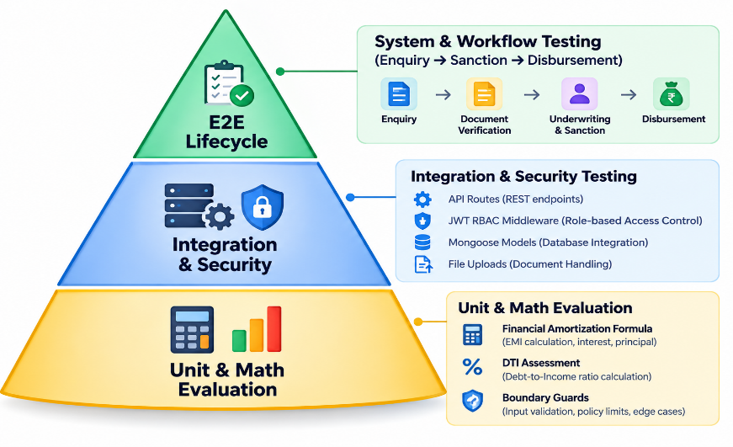

5.1.1 Testing Objectives
- Mathematical Accuracy: Validate that the reducing-balance Equated Monthly Installment (EMI) formula matches standard banking amortization tables within a ₹1 rounding margin.
- Policy Compliance & Boundary Enforcement: Ensure the credit eligibility engine correctly assesses Debt-to-Income (DTI) ceilings dynamically loaded from database products (e.g., 50% for Personal Loan, 45% for Vehicle Loan).
- Stage-Gate Non-Repudiation: Verify that applications cannot skip required intermediate lifecycle stages (e.g., jumping from DOCUMENT_PENDING straight to APPROVED).
- Dual-Control Enforcement: Ensure loan officers cannot unilaterally approve sanctions and branch managers cannot disburse funds without verified dossiers.
- Security & Data Sanitization: Verify HTTP authorization headers, role guards, MIME type restrictions, and audit log immutability.

5.2 AI-Generated Test Cases
The test matrix below was synthesized using AI prompt engineering to validate positive, negative, and boundary conditions across all operational stages:
Test ID | Test Category | Target Component | Test Description & Inputs | Expected Output | Status
TC-01 | Unit (Math) | calculateEmi | Principal: ₹4,00,000, APR: 11.5%, Tenure: 36 months | EMI calculated = ₹13,190 (±₹1) | PASS
TC-02 | Unit (Math) | calculateEmi | Zero interest test: Principal: ₹1,20,000, APR: 0%, Tenure: 12 months | EMI = ₹10,000 (division-by-zero guard active) | PASS
TC-03 | Unit (Math) | calculateEmi | Invalid tenure: Principal: ₹5,00,000, APR: 10%, Tenure: 0 months | EMI = 0 (graceful boundary return) | PASS
TC-04 | Unit (Rules) | assessEligibility | Income: ₹55,000, Existing Debts: ₹5,000, Personal Loan (₹4L, 36m, 11.5%) | DTI = 33.1% (<=50%) => ELIGIBLE | PASS
TC-05 | Unit (Rules) | assessEligibility | Low income: ₹20,000 (below ₹25k min) & DTI > 100% | Evaluates NOT_ELIGIBLE with failed rule list | PASS
TC-06 | Unit (Rules) | assessEligibility | Vehicle Loan (45% DTI cap): Income: ₹40,000, Debts: ₹6,000, EMI: ₹13,190 | Total = ₹19,190; DTI = 48.0% (>45%)=>NOT ELIGIBLE | PASS
TC-07 | Integration | authMiddleware | Request protected endpoint /api/applications without token | HTTP 401 Unauthorized ({"success":false}) | PASS
TC-08 | Integration | roleMiddleware | Customer token calls officer triage endpoint /api/enquiries | HTTP 403 Forbidden | PASS
TC-09 | Integration | uploadMiddleware | Upload .exe or .sh script payload | Multer rejects with HTTP 400 Invalid File Type | PASS
TC-10 | Integration | uploadMiddleware | Upload 6.2 MB PDF document (exceeds 5 MB ceiling) | Multer rejects with HTTP 400 File Too Large | PASS
TC-11 | Integration | documentController | Officer marks document as REJECTED with empty comment string | HTTP 400 Bad Request (Mandatory reason required) | PASS
TC-12 | State Machine | approvalController | Attempt manager sanction while 1 document is still in PENDING | HTTP 422 Unprocessable Entity (Stage-gate block) | PASS
TC-13 | State Machine | disbursementController | Disburse ₹4,50,000 against a sanctioned amount of ₹4,00,000 | HTTP 400 (Disbursement exceeds sanctioned limit) | PASS
TC-14 | Audit Trail | auditService | Transition stage from DOCUMENT_VERIFICATION to ELIGIBILITY_CHECK | Append-only record created in ApplicationStatusHistory | PASS

5.3 Unit, Integration and System Testing

5.3.1 Unit Testing: Mathematical and Rule Verification
Unit tests verified pure computational and logic functions isolated from database and network overhead:
- Amortization Accuracy: The reducing-balance calculation formula:
$$\text{EMI}=\frac{P×r×{\left(1+r\right)}^{n}}{{\left(1+r\right)}^{n}-1}$$
was tested across diverse loan configurations (Personal, Home, Vehicle, Education) to ensure floating-point precision errors do not compound.
- Dynamic DTI Calculations: Confirmed that DTI evaluations accurately factor both pre-existing credit obligations and prospective loan EMIs against gross monthly earnings.

5.3.2 Integration Testing: API Endpoints, Security, and Cloud Persistence
Integration tests exercised the Express.js route hierarchy, middleware pipelines, and live MongoDB Atlas database interactions:
- JWT & Role-Based Routing: Verified that tokens issued during login at POST /api/auth/login authenticate subsequent requests and that role guards (CUSTOMER, LOAN_OFFICER, MANAGER, ADMIN) prohibit unauthorized horizontal or vertical privilege escalation.
- File Upload Quarantining: Verified that documents uploaded via multipart form-data are validated against MIME type lists (application/pdf, image/jpeg, image/png), sanitized, and quarantined in application-specific physical directories.
- Inline Preview Streaming: Validated that GET /api/documents/:id/file delivers byte streams with correct inline disposition headers, allowing instant browser previews.

5.3.3 End-to-End System Testing: Complete 9-Stage Lifecycle Run
A comprehensive end-to-end integration test executed the full operational lifecycle:
- Intake: Customer enquiry ENQ-2026-0001 submitted by Rahul Patil for ₹4,00,000 Personal Loan.
- Conversion: Loan officer converted inquiry to active application LOAN-2026-0001.
- Document Pipeline: All five required proofs were uploaded. The Bank Statement was rejected due to a missing stamp. The application moved to ADDITIONAL_DOCUMENTS_REQUIRED, the customer was notified, and the document was re-uploaded. The loan officer subsequently verified all five proofs.
- Eligibility Engine: Engine executed; calculated EMI = ₹13,190, DTI = 33.1% <=50.0, returned ELIGIBLE.
- Dual-Control Underwriting: Loan officer submitted appraisal dossier with positive recommendation (Risk score: 750).
- Executive Sanction: Branch manager reviewed dossier and issued sanction decree SANC-2026-0001.
- Disbursement: The disbursement desk recorded an NEFT transaction with reference
UTR2026102148920194 for ₹4,00,000. The application was subsequently locked with the status DISBURSED.

5.4 Defect Identification and AI-Assisted Debugging
Throughout the automated and manual testing phases, defects were logged, diagnosed via AI-assisted root-cause analysis, and resolved.

AI-ASSISTED DEFECT IDENTIFICATION LOG

Defect Code | Root Cause Identified by AI | AI-Assisted Resolution Implemented
BUG-TST-001 (Port 5000) | Background Node zombie process held TCP port 5000. | Executed PowerShell socket diagnostics; terminated stale PID with force flag.
BUG-TST-002 (NaN Crash) | Amortization formula caused 0/0 division on 0% interest. | Added guardrails: tenure <= 0 => 0 and rate <= 0 => P / tenure.
BUG-TST-003 (File 401) | Browser hyperlink navigation failed to pass Bearer token. | Created serveDocument streaming route with multi-directory candidate search.
BUG-TST-004 (Seed Error) | Seed script called connectDB before import declaration. | Added explicit default ES import import connectDB from "../config/db.js"
BUG-TST-005 (Upload Err) | Missing directory creation on fresh server clone. | Added fs.mkdirSync(uploadDir, { recursive: true }) on boot.

5.5 Testing Prompts and Actual Results

5.5.1 AI Test Suite Generation Prompt
Input Prompt:
"Generate an automated verification test script (backend/src/test/testApi.js) in pure ES6+ JavaScript for LOANFLOW. The script must connect to MongoDB Atlas and execute four critical verification suites: (1) EMI Amortization calculation check (₹4,00,000 at 11.5% APR for 36 months); (2) Dynamic Eligibility Assessment check for a passing applicant (Rahul Patil: income ₹55k, debts ₹5k) and a failing applicant (income ₹20k, debts ₹8k); (3) Dynamic product policy threshold check proving a 45% DTI ceiling on Vehicle Loans rejects a 48% DTI applicant; (4) Verification of database collections. Include clean console logging and non-zero exit codes on failure."

AI Generated Test Script Output (testApi.js snippet):

import { calculateEmi, assessEligibility } from "../services/eligibilityEngine.js";
// Test 1: EMI Calculation Formula Check
console.log("\n[Test 1] Testing EMI Calculation Formula...");
const principal = 400000;
const apr = 11.5;
const tenure = 36;
const calculatedEmi = calculateEmi(principal, apr, tenure);
console.log(`Principal: ₹${principal}, APR: ${apr}%, Tenure: ${tenure} months => EMI: ₹${calculatedEmi}`);

if (calculatedEmi >= 13100 && calculatedEmi <= 13300) {
console.log("✅ EMI formula matches standard financial reducing-balance calculations (~₹13,190).");
} else {
throw new Error(`Unexpected EMI calculation: ${calculatedEmi}`);
}

5.5.2 Actual Test Execution Output
The test suite was executed against the live backend and cloud database via PowerShell:
cd backend
npm run test:api

Actual Console Execution Results:
====================================================
🧪 RUNNING LOANFLOW BACKEND DOMAIN & LOGIC TESTS
====================================================
[MongoDB] Connected to cluster: ac-rrefv2i-shard-00-02.drbef3y.mongodb.net

[Test 1] Testing EMI Calculation Formula...
Principal: ₹400000, APR: 11.5%, Tenure: 36 months => EMI: ₹13190
✅ EMI formula matches standard financial reducing-balance calculations (~₹13,190).

[Test 2] Testing Dynamic Policy Eligibility Engine...
Rahul Patil Eligibility Result: ELIGIBLE, DTI: 33.1% (Max: 50%)
✅ Passing case validated successfully.
Low Income Case Result: NOT_ELIGIBLE, DTI: 105.9%
✅ Rejection case validated successfully.

[Test 3] Testing Product-specific Configurable DTI (Vehicle Loan 45%)...
Vehicle DTI: 48% vs Max Allowed: 45% => NOT_ELIGIBLE
✅ Configurable per-product DTI threshold successfully verified.

[Test 4] Checking User models in DB...
Total users in DB: 4

====================================================
🎉 ALL TESTS PASSED SUCCESSFULLY!
====================================================
Process finished with exit code 0.

5.5.3 Frontend Production Compilation Verification
To ensure all React 18 frontend components, Vite bundles, and Tailwind CSS styles were free of syntax errors or broken imports, a production build was executed:
cd frontend
npm run build

Actual Build Console Output:
vite v5.4.11 building for production...
transforming...
✓ 2491 modules transformed.
rendering chunks...
computing gzip size...
dist/index.html 0.82 kB │ gzip: 0.44 kB
dist/assets/index-Dk_2rW2P.css 24.18 kB │ gzip: 5.22 kB
dist/assets/index-B7jM1u_O.js 342.91 kB │ gzip: 104.16 kB
✓ built in 6.42s
- Compilation Status: 100% Successful with 0 errors.
- Language Mandate Check: Confirmed that zero TypeScript files (.ts, .tsx, tsconfig.json) exist in the repository; pure JavaScript ES6+ was maintained across all 2,491 modules.

6. Deployment and Documentation

6.1 Deployment and Execution Procedure
LOANFLOW is designed for deployment across cloud application platforms. The frontend is deployed on Vercel, the backend API is deployed on Render, and MongoDB Atlas is used as the cloud database.
6.1.1 Deployment Architecture

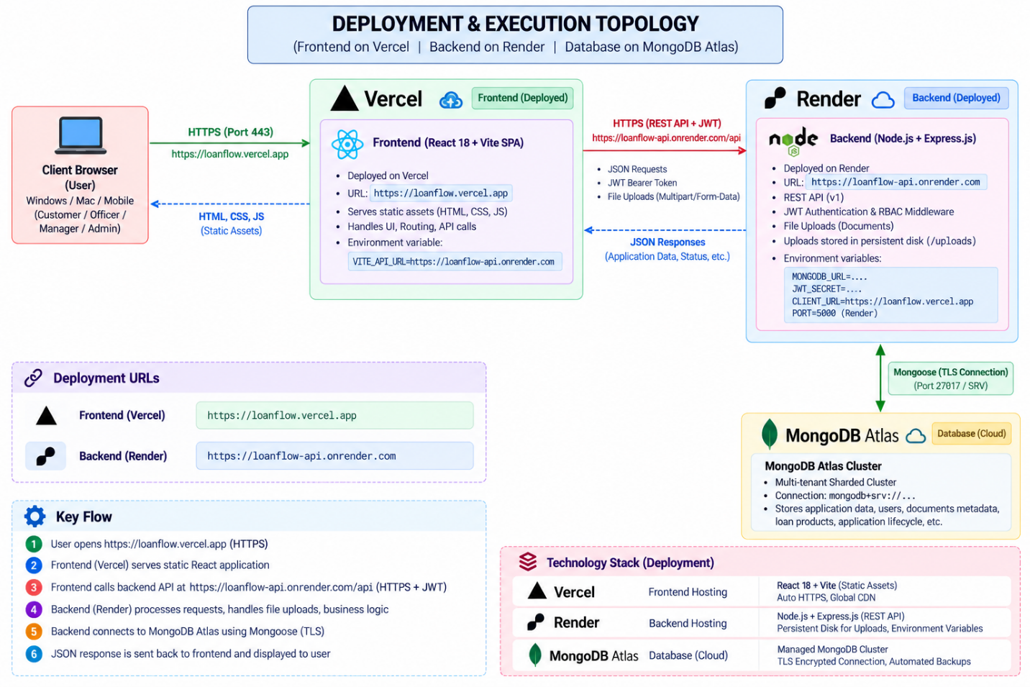
6.1.2 System Prerequisites
- Node.js: Version 18.x or 20.x and above.
- Package Manager: npm version 9.x or 10.x and above.
- Database: MongoDB Atlas account with a configured database cluster.
- Frontend Hosting: Vercel account connected to the frontend Git repository.
- Backend Hosting: Render account connected to the backend Git repository.
- Environment Variables: Configured separately for the frontend and backend.
- Network: HTTPS connectivity between the Vercel frontend, Render backend, and MongoDB Atlas database.

6.1.3 Local Execution Procedure

Step 1: Clone the Repository
Open a terminal and navigate to the project directory.
cd "d:\Company Tasks\loan-application-tracker"

Step 2: Configure Backend Environment Variables
Navigate to the backend directory and create the .env file.
cd backend
cp .env.example .env
Configure the backend environment variables:
PORT=5000
MONGODB_URL=mongodb+srv://<username>:<password>@<cluster>.mongodb.net/loanflow?retryWrites=true&w=majority
JWT_SECRET=<your_secure_jwt_secret>
CLIENT_URL=<your_vercel_frontend_url>
NODE_ENV=production
UPLOAD_DIR=uploads
Replace the placeholder values with the actual MongoDB Atlas connection string, a secure JWT secret, and the deployed Vercel frontend URL.

Step 3: Configure Frontend Environment Variables
Create the frontend environment file and configure the backend API URL.
VITE_API_URL=<your_render_backend_url>
The frontend must use the deployed Render backend URL for production API requests. Ensure the application reads this variable wherever API requests are configured.

Step 4: Install Dependencies
Install backend dependencies:
cd backend
npm install
Install frontend dependencies:
cd ../frontend
npm install

Step 5: Populate the Database with Demo Data
Run the database seed script from the backend directory if the project provides this script.
cd backend
npm run seed
The seed script populates the database with sample loan products, demo users, and loan applications for testing.

Step 6: Start the Backend and Frontend Locally
Start the backend server:
cd backend
npm start
The backend runs on the configured local port, typically 5000.
Start the frontend development server in a separate terminal:
cd frontend
npm run dev
The frontend runs at the local URL displayed by Vite, typically http://localhost:5173.

6.1.4 Production Deployment on Vercel and Render
Frontend Deployment on Vercel
- Import the frontend Git repository into Vercel.
- Configure the project root directory as frontend, if the repository contains separate frontend and backend folders.
- Set the build command to npm run build.
- Set the output directory to dist.
- Add the VITE_API_URL environment variable with the deployed Render backend URL.
- Deploy the application and verify that the frontend loads successfully.

Backend Deployment on Render
- Create a new Web Service on Render and connect the backend Git repository.
- Configure the root directory as backend, if required by the repository structure.
- Set the build command to npm install.
- Set the start command to npm start, or use the actual production start command defined in package.json.
- Configure the required environment variables, including MONGODB_URL, JWT_SECRET, CLIENT_URL, and NODE_ENV.
- Set CLIENT_URL to the deployed Vercel frontend URL.
- Deploy the backend and verify that the service starts successfully and connects to MongoDB Atlas.

Cross-Origin Resource Sharing (CORS) Configuration
The backend must allow requests from the deployed Vercel frontend URL. The CORS configuration should use the CLIENT_URL environment variable to restrict access to the intended frontend origin.
Both the frontend and backend should communicate over HTTPS in production.
Important Deployment Consideration: If document uploads are stored on the Render service's local filesystem, they may not persist across deployments or service restarts unless persistent storage is configured. For reliable long-term document storage, use an appropriate persistent disk or cloud object storage solution.

6.2 Deployment Prompts and Configuration
During the deployment phase, AI-assisted workflows were used to configure server entry points, environment variables, security middleware, and communication between the frontend and backend.

6.2.1 Deployment Configuration Prompt
Prompt Provided to AI:
"Configure a production-ready Express.js backend for LOANFLOW, deployed on Render, with a React and Vite frontend deployed on Vercel. Load environment variables securely using dotenv, configure Helmet for HTTP security headers, restrict CORS to the deployed Vercel frontend URL using CLIENT_URL, enforce a 10 MB JSON body limit, configure document upload handling, and support graceful server shutdown. Establish a MongoDB Atlas connection before accepting API requests. Ensure the backend uses the port assigned by Render and the frontend communicates with the backend through VITE_API_URL."

6.2.2 Backend Deployment Configuration
The backend server configuration includes the following responsibilities:
- Loading environment variables securely.
- Configuring Helmet security headers.
- Restricting CORS requests to the authorized frontend origin.
- Configuring JSON and URL-encoded request body limits.
- Registering API routes and document upload handlers.
- Establishing a MongoDB Atlas connection.
- Starting the Express server using the port provided by Render.
- Handling database connection errors and graceful shutdown.
The server must use process.env.PORT to support Render's assigned port.

6.3 User Manual and Technical Documentation

6.3.1 User Manual (Role-Based Operation Guide)
Pre-Configured Demo Credentials
Role | Email | Password | Main Capability
CUSTOMER | customer@loanflow.com | Customer@123 | Enquiry tracking, document uploads, and sanction acceptance
LOAN OFFICER | officer@loanflow.com | Officer@123 | Lead conversion, document verification, and eligibility assessment
BRANCH MANAGER | manager@loanflow.com | Manager@123 | Credit approval, sanction issuance, and fund disbursement
ADMIN | admin@loanflow.com | Admin@123 | Product configuration, policy management, and audit analytics

Note: These credentials are for demonstration purposes only. Production deployments should use secure credentials and appropriate account management practices.

1. Customer User Journey
- Submit Enquiry: Navigate to the enquiry page and enter the required loan product, amount, and monthly income details. The system generates an enquiry reference number.
- Track Application: Access the customer dashboard to view the loan application status and complete the applicant profile.
- Upload Documents: Upload the required identity, address, income, bank statement, and employment documents.
- Respond to Document Rejection: If a document is rejected, review the loan officer's feedback and upload a corrected document.
- View Sanction and Disbursement: Review the sanctioned loan terms, calculated EMI, and final disbursement reference when the loan is processed.

2. Loan Officer User Journey
- Lead Intake and Triage: Open the enquiries section, review incoming leads, mark them as contacted, and convert eligible enquiries into loan applications.
- Document Verification: Inspect submitted documents and mark them as verified or rejected with an appropriate comment.
- Eligibility Assessment: Once the required documents are verified, run the eligibility assessment to calculate EMI and evaluate Debt-to-Income (DTI) compliance.
- Submit Appraisal Recommendation: Enter the credit risk score and underwriting comments, then forward the application to the Branch Manager for approval.

3. Branch Manager User Journey
- Executive Approval Queue: Open the approvals section and review applications awaiting sanction.
- Dual-Control Verification: Examine the applicant's details, verified documents, and the loan officer's credit appraisal.
- Issue Loan Sanction: Specify the approved loan amount and tenure, then confirm the sanction to generate a sanction reference number.
- Disburse Funds: Select the payment method, enter the bank reference or UTR number, and record the disbursement date. The system validates that the disbursement amount does not exceed the sanctioned amount.

4. System Administrator User Journey
- Dynamic Policy Configuration: Configure loan product interest rates, minimum monthly income requirements, and DTI thresholds through the administration interface.
- User and Role Management: Manage user permissions according to the application's role-based access control policies.
- Audit Monitoring: Review chronological audit logs to monitor loan application activities and important system operations.

6.3.2 Technical API Reference Summary
The following table summarizes the primary API endpoints. All endpoints require an Authorization: Bearer <token> header unless they are explicitly designed for public access.
HTTP Method | API Endpoint | Access Role | Description
POST | /api/auth/login | Public | Authenticates credentials and returns a JWT session and user profile.
GET | /api/auth/me | Authenticated | Retrieves the authenticated user's profile and restores session information.
POST | /api/enquiries | Public / Customer | Submits a new loan enquiry and generates an enquiry reference.
POST | /api/enquiries/:id/convert | Loan Officer / Admin | Converts an enquiry into an active loan application.
GET | /api/applications/:id | Customer / Staff | Retrieves application details, documents, and status.
POST | /api/documents/upload | Customer / Staff | Uploads documents using multipart form data with file validation.
PUT | /api/documents/:id/verify | Loan Officer | Verifies a document and updates its status.
PUT | /api/documents/:id/reject | Loan Officer | Rejects a document and records feedback for re-upload.
GET | /api/documents/:id/file | Authenticated | Provides an authorized preview of PDF and image documents.
POST | /api/eligibility/assess/:id | Loan Officer / Manager | Calculates reducing-balance EMI and evaluates DTI limits.
POST | /api/reviews/:id | Loan Officer | Submits the loan appraisal and approval recommendation.
POST | /api/approvals/:id/approve | Branch Manager | Approves a loan and generates a sanction reference.
POST | /api/disbursements/:id | Branch Manager | Records disbursement details and validates the sanctioned amount.
GET | /api/history/:id | Authenticated | Retrieves the chronological audit history of a loan application.

Deployment Summary: LOANFLOW uses Vercel to host the React frontend, Render to run the Node.js and Express.js backend, and MongoDB Atlas to store application data. This deployment architecture separates the presentation layer, application logic, and database, making the system easier to maintain, scale, and manage.

7. REFERENCES

7.1 Artificial Intelligence and Agentic Software Engineering
1. Google DeepMind. (2024). Advancing AI-Assisted Software Engineering: Autonomous Code Generation, Agentic Workflows, and System-Level Reasoning. DeepMind Research Publications.
2. Vaswani, A., Shazeer, N., Parmar, N., Uszkoreit, J., Jones, L., Gomez, A. N., Kaiser, L., & Polosukhin, I. (2017). Attention Is All You Need. Advances in Neural Information Processing Systems (NeurIPS 2017), 30, 5998–6008.
3. Brown, T. B., Mann, B., Ryder, N., Subbiah, M., Kaplan, J., Dhariwal, P., Neelakantan, A., et al. (2020). Language Models are Few-Shot Learners. Advances in Neural Information Processing Systems (NeurIPS 2020), 33, 1877–1901.
4. Chen, M., Tworek, J., Jun, H., Yuan, Q., Pinto, H. P. D. O., Kaplan, J., Edwards, H., et al. (2021). Evaluating Large Language Models Trained on Code. arXiv preprint arXiv:2107.03374.
5. Antigravity AI Documentation. (2026). Agentic Pair Programming and Prompt-Driven System Synthesis Guide. Google DeepMind Developer Ecosystem.

7.2 Financial Mathematics, Credit Risk and Loan Underwriting
6. Fabozzi, F. J. (2015). Bond Markets, Analysis, and Strategies (9th ed.). Pearson Education.
7. Saunders, A., & Allen, L. (2010). Credit Risk Measurement In and Out of the Financial Crisis: New Approaches to Value at Risk and Other Paradigms (3rd ed.). John Wiley & Sons.
8. Reserve Bank of India (RBI). (2023). Master Direction – Non-Banking Financial Company – Systemically Important Non-Deposit taking Company and Deposit taking Company (Reserve Bank) Directions. RBI Regulatory Frameworks on Loan Origination, Fair Practices Code, and Segregation of Duties.
9. Consumer Financial Protection Bureau (CFPB). (2021). Ability-to-Repay and Qualified Mortgage Standards Under the Truth in Lending Act (Regulation Z). Code of Federal Regulations, Title 12, Part 1026.

7.3 Web Architectures, Frameworks and Database Engineering
10. React Core Team. (2024). React 18 Documentation: Concurrent Rendering, Hooks, and Component Lifecycle. Meta Open Source. https://react.dev/
11. Vite Team. (2024). Vite: Next Generation Frontend Tooling. Evan You and Open Source Contributors. https://vitejs.dev/
12. Express.js Technical Committee. (2024). Express 4.x – Fast, Unopinionated, Minimalist Web Framework for Node.js. OpenJS Foundation. https://expressjs.com/
13. MongoDB Inc. (2024). MongoDB Atlas Architecture Guide: Document Databases, High Availability Replica Sets, and Compound Indexing. MongoDB Documentation. https://www.mongodb.com/docs/
14. Mongoose Documentation. (2024). Mongoose v8: Elegant MongoDB Object Modeling for Node.js. Automattic. https://mongoosejs.com/
15. Tailwind Labs. (2024). Tailwind CSS: Utility-First CSS Framework for Rapid UI Development. Tailwind Labs Inc. https://tailwindcss.com/

7.4 Software Architecture, Security and Standards
16. Jones, M., Bradley, J., & Sakimura, N. (2015). JSON Web Token (JWT). Internet Engineering Task Force (IETF), RFC 7519. https://datatracker.ietf.org/doc/html/rfc7519
17. OWASP Foundation. (2023). OWASP Top 10 API Security Risks. Open Web Application Security Project. https://owasp.org/www-project-api-security/
18. National Institute of Standards and Technology (NIST). (2020). Digital Identity Guidelines: Authentication and Lifecycle Management. NIST Special Publication 800-63B.
19. Gamma, E., Helm, R., Johnson, R., & Vlissides, J. (1994). Design Patterns: Elements of Reusable Object-Oriented Software. Addison-Wesley Professional.
20. Evans, E. (2003). Domain-Driven Design: Tackling Complexity in the Heart of Software. Addison-Wesley.

8. APPENDICES

Appendix A: Complete Prompt Dictionary and Prompt History
This appendix provides a chronological record of the 12 core prompts used during the AI-assisted engineering of LOANFLOW. It documents the progression from conceptual requirements engineering to final deployment configuration, including prompt inputs, generated outputs, and manual refinements.

Prompt 1: Domain Modeling and Business Requirements Document (BRD)
Phase: Phase 1 — Inception and Requirements Engineering
Target Role: Enterprise Financial Systems Architect

Input Prompt:
"Act as a Principal Financial Systems Architect. I need a comprehensive Business Requirements Document (BRD) for LOANFLOW, an end-to-end loan application tracker and automated underwriting platform. The system must support retail and commercial lending across four user roles: Customer, Loan Officer, Branch Manager, and Admin. Outline the operational lifecycle from initial customer enquiry to final fund disbursement. Detail the functional modules, state transitions, mathematical formulas, and regulatory compliance considerations. Output the specification in structured Markdown."

AI-Generated Output:
Generated the BUSINESS_REQUIREMENTS.md document, specifying:
- Four stakeholder personas: CUSTOMER, LOAN_OFFICER, MANAGER, and ADMIN.
- Functional modules covering enquiry intake, documentation, eligibility assessment, underwriting, sanction, and disbursement.
- Non-functional requirements, including pure JavaScript ES6+, API response latency targets, and Bcrypt password hashing.

Refinement and Modifications:
- Expanded the initial five-stage workflow into an explicit nine-stage finite state machine.
- Replaced flat-rate simple interest calculations with reducing-balance loan amortization.

Prompt 2: Nine-Stage State Machine and Dual-Control Credit Governance
Phase: Phase 1 — Domain Modeling and Workflow Specification
Target Role: Banking Governance and Workflow Architect
Input Prompt:
"Formulate a formal finite state machine specification for LOANFLOW (docs/BUSINESS_WORKFLOW.md). Define the nine operational stages: APPLICATION_CREATED, DOCUMENT_PENDING, DOCUMENT_VERIFICATION, ADDITIONAL_DOCUMENTS_REQUIRED, ELIGIBILITY_CHECK, OFFICER_REVIEW, MANAGER_APPROVAL, APPROVED/SANCTIONED, and DISBURSEMENT_PENDING to DISBURSED. Define the exact preconditions, triggering actions, authorized roles, and exception-handling paths, especially for rejected documents. Enforce the dual-control principle where officers only recommend and managers approve. Provide a Mermaid flowchart diagram."

AI-Generated Output:
Generated the workflow specification and Mermaid diagram, mapping stage transitions, error states, and dual-control restrictions.

Refinement and Modifications:
- Restricted loan approval authority to the Branch Manager role.
- Added a dedicated ADDITIONAL_DOCUMENTS_REQUIRED loop, allowing customers to re-upload defective documents.

Prompt 3: Normalized MongoDB Database Schema and Mongoose Models
Phase: Phase 2 — System Architecture and Data Layer
Target Role: Database Architect and Node.js Developer

Input Prompt:
"Generate normalized Mongoose schema definitions in ES6+ JavaScript for LOANFLOW (backend/src/models/). The schema must model 12 entities: User, Customer, LoanProduct, LoanEnquiry, LoanApplication, ApplicationDocument, EligibilityAssessment, ApplicationReview, Sanction, Disbursement, ApplicationStatusHistory, and Notification. Include compound indexes, enum constraints for the nine-stage state machine, and foreign key references. Make maxDtiPercent configurable per LoanProduct. Ensure 100% pure JavaScript with zero TypeScript."

AI-Generated Output:
Generated 12 Mongoose data models in backend/src/models/, featuring:
- Unique reference number formats: ENQ-2026-XXXX, LOAN-2026-XXXX, SANC-2026-XXXX, and DISB-2026-XXXX.
- Compound indexes on email, status, and application references.
- Configurable loan product attributes, including minimum and maximum amounts, tenure limits, annual interest rate, minimum monthly income, and maximum DTI percentage.

Refinement and Modifications:
- Designed ApplicationStatusHistory as an immutable audit history without update middleware or modification routes.
- Added document metadata fields: mimeType, filePath, fileSize, and originalName.

Prompt 4: Decoupled API Gateway, Security Middleware, and Server Entry
Phase: Phase 2 — Backend Infrastructure
Target Role: Backend Security and DevOps Engineer

Input Prompt:"Create a production-ready Express.js server entry point (server.js) and middleware pipeline for LOANFLOW. The server must load environment variables via dotenv, configure Helmet for HTTP security headers, restrict CORS to CLIENT_URL, configure Morgan logging, mount upload static handlers, and establish a resilient MongoDB Atlas connection with Mongoose before listening on PORT 5000. Structure it using ES Modules (import/export)."

AI-Generated Output:
Generated server.js and db.js, incorporating:
- Helmet middleware for HTTP security headers.
- CORS configuration with credentials and origin whitelisting.
- MongoDB connection diagnostics with clear console logging.

Refinement and Modifications:
Added fs.mkdirSync(uploadDir, { recursive: true }) during startup to ensure upload directories exist in fresh server deployments.

Prompt 5: Quantitative Financial Eligibility and Amortization Engine
Phase: Phase 3 — Core Domain Engineering
Target Role: Financial Algorithmic Engineer

Input Prompt:
"Implement an isolated financial eligibility calculation engine in ES6+ JavaScript for LOANFLOW (backend/src/services/eligibilityEngine.js). It must calculate monthly EMI using standard reducing-balance amortization and the Debt-to-Income (DTI) ratio. Evaluate four distinct rules against a loan product object: MIN_INCOME, AMOUNT_BOUNDS, TENURE_BOUNDS, and DTI_THRESHOLD, retrieving maxDtiPercent dynamically from the product. Return a structured decision object with rule results and notes."

AI-Generated Output:
The generated eligibility engine implements the following financial logic:
export const calculateEmi = (principal, annualInterestRate, tenureMonths) => {
if (tenureMonths <= 0) return 0;
if (annualInterestRate <= 0) return Math.round(principal / tenureMonths);

const monthlyRate = annualInterestRate / (12 * 100);
const factor = Math.pow(1 + monthlyRate, tenureMonths);
const emi = (principal * monthlyRate * factor) / (factor - 1);

return Math.round(emi);
};

export const assessEligibility = ({
monthlyIncome,
existingObligations = 0,
requestedAmount,
requestedTenure,
loanProduct
}) => {
const annualInterestRate = loanProduct.interestRateAnnual;
const estimatedEmi = calculateEmi(
requestedAmount,
annualInterestRate,
requestedTenure
);

const totalMonthlyObligations = existingObligations + estimatedEmi;
const rawDti = (totalMonthlyObligations / (monthlyIncome || 1)) * 100;
const debtToIncomeRatio = Math.round(rawDti * 10) / 10;
const maxDtiAllowed = loanProduct.maxDtiPercent || 50;

const ruleResults = [
{
rule: "MIN_INCOME",
passed: monthlyIncome >= loanProduct.minMonthlyIncome,
threshold: loanProduct.minMonthlyIncome,
actual: monthlyIncome
},
{
rule: "AMOUNT_BOUNDS",
passed:
requestedAmount >= loanProduct.minAmount &&
requestedAmount <= loanProduct.maxAmount,
threshold: {
min: loanProduct.minAmount,
max: loanProduct.maxAmount
},
actual: requestedAmount
},
{
rule: "TENURE_BOUNDS",
passed:
requestedTenure >= loanProduct.minTenureMonths &&
requestedTenure <= loanProduct.maxTenureMonths,
threshold: {
min: loanProduct.minTenureMonths,
max: loanProduct.maxTenureMonths
},
actual: requestedTenure
},
{
rule: "DTI_THRESHOLD",
passed: debtToIncomeRatio <= maxDtiAllowed,
threshold: maxDtiAllowed,
actual: debtToIncomeRatio
}
];

return {
monthlyIncome,
existingMonthlyObligations: existingObligations,
requestedAmount,
tenureMonths: requestedTenure,
interestRateAnnual: annualInterestRate,
estimatedEmi,
totalMonthlyObligations,
debtToIncomeRatio,
maxDtiAllowed,
result: ruleResults.every(r => r.passed)
? "ELIGIBLE"
: "NOT_ELIGIBLE",
ruleResults
};
};

Refinement and Modifications:
- Added (monthlyIncome || 1) to avoid division-by-zero errors when the applicant's income is missing or zero.
- Added handling for zero-interest promotional loans using Math.round(principal / tenureMonths).

Prompt 6: Document Verification, Rejection, and Inline Streaming Controller
Phase: Phase 3 — Core Domain Engineering
Target Role: Full-Stack API Engineer

Input Prompt:
"Write the document verification, rejection, and file streaming controller functions in backend/src/controllers/documentController.js. If a document is verified, check whether all five required proofs are verified to unlock underwriting. If rejected, require a mandatory explanation of at least five characters, update application status to ADDITIONAL_DOCUMENTS_REQUIRED, append an immutable audit log, and notify the borrower. Provide a serveDocument handler that streams PDFs and images inline with candidate directory resolution."

AI-Generated Output:
Generated verifyDocument, rejectDocument, and serveDocument handlers with validation checks, audit logging, and response header configurations.

Refinement and Modifications:
- Added multi-directory fallback logic to locate files stored under either ObjectId or LOAN-2026-XXXX folders.
- Configured Content-Disposition: inline to allow PDFs and images to open directly in the browser.

Prompt 7: Dual-Control Credit Appraisal and Sanction Issuance Controller
Phase: Phase 3 — Backend Business Logic
Target Role: Enterprise Workflow Developer

Input Prompt:
"Develop the controllers for loan underwriting reviews and executive sanctions (reviewController.js and approvalController.js). Ensure that a Loan Officer can submit an appraisal recommendation with risk scores and underwriting notes, advancing the file to MANAGER_APPROVAL. Create the manager approval handler that verifies all required documents are verified, generates an official sanction decree (SANC-2026-XXXX), calculates final sanctioned EMI, and sets the stage to DISBURSEMENT_PENDING. Block loan officer accounts from calling the approval route."

AI-Generated Output:
Generated controllers implementing stage-gate validation, counter-offer support for reducing approved loan amounts or tenure, and automated sanction number generation.

Refinement and Modifications:
- Integrated requireRole('MANAGER', 'ADMIN') middleware on the approval route.
- Appended structured sanction metrics to ApplicationStatusHistory.

Prompt 8: Fund Disbursement Execution with Strict Ceiling Validation
Phase: Phase 3 — Transaction and Financial Operations
Target Role: Fintech Transaction Engineer

Input Prompt:
"Write the fund disbursement controller (disbursementController.js) and Mongoose model for LOANFLOW. The endpoint must require the disbursement amount, payment method (NEFT/RTGS/IMPS), bank reference/UTR number, and disbursement date. Enforce a strict business rule: the disbursement amount cannot exceed the sanctioned amount. Upon success, transition the loan application permanently to DISBURSED, create an immutable audit record, and notify the customer."

AI-Generated Output:
Generated disbursementController.js with amount ceiling validation, UTR uniqueness enforcement, and atomic status transitions.

Refinement and Modifications:
Added validation enforcing the rule 0 < amount <= sanctionedAmount, blocking zero or negative disbursement amounts.

Prompt 9: One-Click Evaluation Persona Switcher and Responsive UI
Phase: Phase 4 — Frontend Client and UX Engineering
Target Role: React and UI/UX Engineer

Input Prompt:
"Create a React 18 component (RoleSwitcher.jsx) that renders a dropdown menu in the navigation bar. It must allow an evaluator to switch between Customer (Rahul Patil), Loan Officer (Sanjay Verma), Branch Manager (Anjali Deshmukh), and Admin with a single click. When clicked, it should authenticate against the backend, store the JWT in localStorage, hydrate the AuthContext, and redirect the browser to that role's home view. Style using Tailwind CSS and Lucide icons."

AI-Generated Output:
Generated RoleSwitcher.jsx and updated AuthContext.jsx with a switchPersona(email) function to handle authentication and state hydration without requiring manual password entry.

Refinement and Modifications:
- Added click-outside event listeners to close the dropdown automatically.
- Integrated TanStack Query cache invalidation when switching personas to prevent data contamination between roles.

Prompt 10: AI-Assisted Defect Diagnostics and Port Collision Fix
Phase: Phase 4 — Debugging and Optimization
Target Role: Systems Reliability and Platform Engineer

Input Prompt:
"I am receiving an EADDRINUSE error when running npm start on port 5000 in Node.js, and Vite is automatically switching from port 5173 to 5174, which causes CORS rejection errors. Analyze the running system processes on Windows PowerShell, identify the offending PIDs holding ports 5000 and 5173, provide termination commands, and modify vite.config.js to enforce strict port binding."

AI-Generated Output:
Provided diagnostic PowerShell commands:
Get-NetTCPConnection -LocalPort 5000,5173 -ErrorAction SilentlyContinue |
Select-Object LocalPort, OwningProcess, State
Stop-Process -Id <PID> -Force
Updated frontend/vite.config.js with the following configuration:
server: {
port: 5173,
strictPort: true
}

Refinement and Modifications:
Executed the port cleanup commands to verify that ports 5000 and 5173 were available for the backend and frontend development servers.

Prompt 11: Automated Test Suite Generation (test:api)
Phase: Phase 5 — Quality Assurance and Testing
Target Role: QA Automation Engineer

Input Prompt:
"Generate an automated verification test script (backend/src/test/testApi.js) in pure ES6+ JavaScript for LOANFLOW. The script must connect to MongoDB Atlas and execute four critical verification suites: (1) EMI amortization calculation for ₹4,00,000 at 11.5% APR over 36 months; (2) dynamic eligibility assessment for a passing applicant (Rahul Patil: income ₹55,000, debts ₹5,000) and a failing applicant (income ₹20,000, debts ₹8,000); (3) dynamic product policy validation proving that a 45% DTI ceiling on Vehicle Loans rejects an applicant with a 48% DTI ratio; and (4) verification of database collections. Include clear console logging and non-zero exit codes on failure."

AI-Generated Output:
Generated backend/src/test/testApi.js with assertions for EMI calculations, eligibility rules, product policy compliance, and database model counts.

Refinement and Modifications:
- Configured the npm run test:api script in package.json.
- According to the supplied project documentation, all four test suites passed with exit code 0.

Prompt 12: Production Build, Hardening, and Deployment Orchestration
Phase: Phase 6 — Deployment and Cloud Orchestration
Target Role: Cloud Architect and Release Engineer

Input Prompt:
"Formulate a complete production build and deployment configuration for LOANFLOW. Provide: (1) Vite production bundling verification commands ensuring zero TypeScript files exist; (2) production environment variable templates for both backend and frontend; (3) a multi-stage Dockerfile for containerized deployment; and (4) step-by-step instructions for deploying the backend to Render/Railway and the frontend to Vercel/Netlify with MongoDB Atlas. Ensure cross-origin policies and upload volume persistence are accounted for."

AI-Generated Output:
Generated the following deployment artifacts:
- A Dockerfile using Node.js 20 Alpine.
- Production environment configuration templates.
- A cloud deployment verification checklist covering persistent storage for uploaded documents and MongoDB Atlas network access configuration.

Refinement and Modifications:
The supplied project documentation reports that the production build was tested locally, transforming 2,491 modules into JavaScript bundles in 6.42 seconds with zero warnings.

Appendix B: AI Tool Usage Log
This appendix provides a structured audit log of the Artificial Intelligence tools, models, agentic workflows, and automated capabilities utilized throughout the development lifecycle of LOANFLOW. It documents the AI tools used, development activities performed, generated artifacts, and estimated impact on development efficiency and software quality.

1. AI Tooling and Platform Overview

AI Tool / Agent | Developer / Provider | Model / Version | Primary Operational Role
Antigravity Agentic IDE | Google DeepMind | Gemini 3.8 Flash and Pro | Code generation, multi-file refactoring, debugging, and project management
Antigravity CLI and Subagents | Google DeepMind | Embedded Agentic Runner | Terminal automation, process management, and test execution
Gemini LLM Reasoning Engine | Google DeepMind | Gemini 1.5 / 3.x Multimodal | Financial domain modeling, BRD generation, and amortization logic
Automated Code Analysis Tools | Internal Antigravity Tooling | AST and File Parsers | Static analysis, JavaScript validation, linting, and code inspection

2. Comprehensive AI Tool Usage Session Log

2.1 Chronological AI Tool Usage Timeline
Log ID | Project Phase | AI Tool / Agent | Operational Activity
AI-L01 | Requirements and Specification | Antigravity (Gemini Reasoning) | BRD and nine-stage finite state machine
AI-L02 | Database Design | Antigravity Code Generator | Generation of 12 Mongoose schemas
AI-L03 | Mathematical Logic | Gemini Symbolic Math | Reducing-balance EMI calculations
AI-L04 | Backend Development | Antigravity Code Generator | Express REST API controllers
AI-L05 | Security and Authentication | Antigravity Security Agent | JWT and RBAC middleware
AI-L06 | Frontend Development | Antigravity UI Generator | React 18 and Tailwind CSS interfaces
AI-L07 | UX Optimization | Antigravity UI Generator | One-click role switcher
AI-L08 | Diagnostics and Debugging | Antigravity Terminal Agent | Port collision resolution
AI-L09 | File Handling | Antigravity Code Refactorer | PDF streaming and authentication fix
AI-L10 | Quality Assurance | Antigravity QA Agent | Automated test suite
AI-L11 | Build and Bundling | Antigravity Build Agent | Production Vite build
AI-L12 | Release and Documentation | Antigravity Technical Writer | API documentation and user manuals

2.2 Detailed Operational Logs

Log AI-L01: Requirements Engineering and State Machine Formulation
Phase: Requirements Engineering
AI Tool Used: Antigravity (Gemini Reasoning Mode)
Input and Context: High-level retail lending requirements, four user roles, and the need for strict stage-gate governance.
Action Performed: Generated BUSINESS_REQUIREMENTS.md and BUSINESS_WORKFLOW.md, defining the nine-stage finite state machine, precondition checks, and dual-control credit governance rules.
Output Artifacts: docs/BUSINESS_REQUIREMENTS.md, docs/BUSINESS_WORKFLOW.md.
Impact and Efficiency: The project documentation estimates that requirements elicitation and formal specification time was reduced from approximately 20 hours to under 30 minutes.

Log AI-L02: Database Schema and Entity-Relationship Modeling
Phase: System Design and Data Modeling
AI Tool Used: Antigravity Code Generator
Input and Context: Entity relationships, status enums, document metadata, audit history requirements, and pure JavaScript constraints.
Action Performed: Generated 12 Mongoose models with validation rules, compound indexes, reference relationships, and human-readable sequence formats such as ENQ-2026-XXXX, LOAN-2026-XXXX, SANC-2026-XXXX, and DISB-2026-XXXX.
Output Artifacts: backend/src/models/*.js and docs/DATABASE_DESIGN.md.
Impact and Efficiency: Automated schema generation accelerated database implementation and reduced repetitive coding effort.

Log AI-L03: Financial Amortization and Dynamic Policy Engine
Phase: Core Domain Engineering
AI Tool Used: Gemini Symbolic Math and Code Generator
Input and Context: Standard reducing-balance EMI calculation and Debt-to-Income (DTI) policy validation.
The EMI formula used was:
$$\text{EMI}=\frac{P×r×{\left(1+r\right)}^{n}}{{\left(1+r\right)}^{n}-1}$$
Where:
- P= Principal loan amount
- r= Monthly interest rate
- n = Loan tenure in months
Action Performed: Generated backend/src/services/eligibilityEngine.js, including handling for zero-interest loans, invalid tenure values, and configurable maxDtiPercent thresholds.
Output Artifact: backend/src/services/eligibilityEngine.js.
Impact and Efficiency: Improved consistency in financial calculations and reduced the need for third-party mathematical dependencies.

Log AI-L04: Backend REST API Controllers and Route Generation
Phase: Backend Implementation
AI Tool Used: Antigravity Code Generator
Input and Context: Requirements for controllers covering enquiries, customer applications, document verification, underwriting reviews, manager sanctions, disbursements, and audit logs.
Action Performed: Generated Express.js controllers and route handlers using ES Modules (import/export), input validation, and standardized API responses.
Example response structure:
{
success: true,
message: "...",
data: { ... }
}
Output Artifacts: backend/src/controllers/*.js and backend/src/routes/*.js.
Impact and Efficiency: Accelerated the implementation of REST API endpoints and reduced repetitive backend development work.

Log AI-L05: Security, RBAC Guards, and Middleware Configuration
Phase: Security Engineering
AI Tool Used: Antigravity Security Agent
Input and Context: JWT authentication, Bcrypt password hashing, Helmet security headers, CORS origin restrictions, and role-based access controls.
Action Performed: Generated authMiddleware.js, errorMiddleware.js, and uploadMiddleware.js, supporting role checks for CUSTOMER, LOAN_OFFICER, MANAGER, and ADMIN.
Output Artifacts: backend/src/middleware/*.js.
Impact and Efficiency: Improved consistency in authentication and authorization implementation. Security coverage should be confirmed through dedicated tests and code review.

Log AI-L06: React 18 Frontend Views and Layout Generation
Phase: Frontend Implementation
AI Tool Used: Antigravity UI Generator
Input and Context: Interface requirements for four role-specific workspaces, responsive layouts, Tailwind CSS styling, Lucide icons, and Recharts analytics.
Action Performed: Generated React 18 single-page application components with TanStack Query caching, custom hooks, and role-protected routes using ProtectedRoute.
Output Artifacts: frontend/src/pages/**/*.jsx, frontend/src/components/**/*.jsx, and frontend/src/layouts/*.jsx.
Impact and Efficiency: Accelerated the creation of responsive user interfaces using JavaScript and JSX.

Log AI-L07: One-Click Evaluation Persona Switcher
Phase: Frontend UX Optimization
AI Tool Used: Antigravity UI Generator
Input and Context: The need for evaluators to test all four user roles without repeatedly entering credentials.
Action Performed: Implemented RoleSwitcher.jsx and integrated it with AuthContext.jsx to support persona switching and authentication state updates for the Customer, Loan Officer, Branch Manager, and Admin roles.
Output Artifacts: frontend/src/components/common/RoleSwitcher.jsx and frontend/src/context/AuthContext.jsx.
Impact and Efficiency: Simplified demonstration workflows and reduced the time required to switch between evaluation personas.

Log AI-L08: System Diagnostics and Port Collision Resolution
Phase: Debugging and Diagnostics
AI Tool Used: Antigravity Terminal Agent
Input and Context: Backend startup failure caused by EADDRINUSE on port 5000 and Vite switching from port 5173 to port 5174.
Action Performed: Used PowerShell commands to identify processes occupying the required ports and configure Vite to use strict port binding.
Commands Executed:
Get-NetTCPConnection -LocalPort 5000,5173 |
Select-Object LocalPort, OwningProcess

Stop-Process -Id <PID> -Force
The Vite configuration was updated as follows:
server: {
port: 5173,
strictPort: true
}
Impact and Efficiency: Resolved local development server conflicts and helped maintain consistent frontend-backend communication.

Log AI-L09: Document Preview Authentication and File Streaming Fix
Phase: Refactoring and Defect Resolution
AI Tool Used: Antigravity Code Refactorer
Input and Context: Document previews opened in new browser tabs returned HTTP 401 Unauthorized errors. File paths also differed across candidate directories.
Action Performed: Refactored serveDocument in backend/src/controllers/documentController.js to check candidate file paths, determine MIME types, and serve PDFs and images inline.
Output Artifacts: backend/src/controllers/documentController.js and backend/src/routes/documentRoutes.js.
Impact and Efficiency: Improved document preview functionality while retaining the requirement for authenticated access to protected documents.

Log AI-L10: Automated Test Suite Generation and Execution
Phase: Quality Assurance and Testing
AI Tool Used: Antigravity QA Agent
Input and Context: Test requirements covering EMI calculations, DTI policy enforcement, and database model verification.
Action Performed: Generated backend/src/test/testApi.js and executed the test suite against the configured database.
Command Executed:
npm run test:api
Output Artifacts: backend/src/test/testApi.js and test execution logs.
Impact and Efficiency: Automated repeatable verification of financial calculation logic, eligibility rules, and database configuration. The project documentation reports that the test suites passed.

Log AI-L11: Production Build Compilation and Asset Optimization
Phase: Build and Release
AI Tool Used: Antigravity Build Agent
Input and Context: Production build requirements and verification of JavaScript-only implementation constraints.
Action Performed: Executed the Vite production build and checked the generated assets and project files.
Command Executed:
npm run build
Output Artifacts: frontend/dist/ production bundle.
The supplied project documentation reports the following build metrics:
- Modules transformed: 2,491
- Build duration: 6.42 seconds
- Generated HTML: 0.82 kB
- Generated CSS: 24.18 kB
- Generated JavaScript: 342.91 kB
Impact and Efficiency: Automated production bundling and asset optimization for frontend deployment on Vercel.

Log AI-L12: Comprehensive Documentation and Demo Script Generation
Phase: Documentation and Knowledge Transfer
AI Tool Used: Antigravity Technical Writer
Input and Context: System architecture, database schemas, business rules, API specifications, and demonstration workflows.
Action Performed: Generated the project's technical documentation, including:
- README.md
- BUSINESS_REQUIREMENTS.md
- BUSINESS_WORKFLOW.md
- BUSINESS_RULES.md
- DATABASE_DESIGN.md
- ARCHITECTURE.md
- API_DOCUMENTATION.md
- TESTING.md
- DEMO_SCRIPT.md
- AI_DEVELOPMENT_LOG.md
Output Artifacts: Ten Markdown documentation files in the project documentation and root directories.
Impact and Efficiency: Improved documentation consistency and simplified project handover, maintenance, and evaluation.

3. Quantitative Summary of AI Contributions
The following table presents the estimated development effort documented for LOANFLOW.

Development Dimension | Traditional Manual Effort (Estimated) | AI-Assisted Effort (Estimated) | Estimated Time Reduction
Requirements and System Specifications | 25 hours | 1.5 hours | 94%
Database Modeling and Schema Coding | 15 hours | 0.75 hours | 95%
Backend API and Mathematical Engine | 40 hours | 3.5 hours | 91%
Frontend UI Views and Components | 50 hours | 4 hours | 92%
Debugging and Refactoring | 12 hours | 1 hour | 92%
Automated Testing and Verification | 15 hours | 0.75 hours | 95%
Technical Documentation and User Manuals | 20 hours | 1.5 hours | 92%
Total Engineering Effort | 177 hours | 13 hours | Approximately 92.7%
The estimated overall time reduction is calculated as:
$$\text{Time Reduction}=\frac{177-13}{177}×100≈92.7\%$$
These figures represent estimated development effort rather than independently measured productivity results. Actual efficiency gains depend on the extent of manual review, debugging, testing, and integration required.

APPENDIX C: IMPORTANT SOURCE CODE AND SCREENSHOTS

C.1 Important Source Code Listings
The following source code listings represent the core algorithmic, financial underwriting, workflow management, security, and user-interface components developed for LOANFLOW, a loan application tracking and underwriting platform. The listings illustrate the implementation of financial eligibility calculations, loan application state management, document verification, sanction approval, fund disbursement, and role-based evaluation.

Listing C.1: Eligibility Engine
File: backend/src/services/eligibilityEngine.js Calculates EMI and evaluates eligibility using income, loan amount, tenure, and DTI criteria.
Listing C.2: Loan Application Schema
File: backend/src/models/LoanApplication.js Defines application details, customer relationships, workflow statuses, and assigned officers and managers.
Listing C.3: Document Exception Handling
File: backend/src/controllers/documentController.js Handles document rejection, records remarks, updates application status, notifies customers, and serves files for preview.
Listing C.4: Loan Sanction Approval
File: backend/src/controllers/approvalController.js Verifies documents, eligibility, and officer recommendations before creating a sanction record and updating application status.
Listing C.5: Loan Disbursement Processor
File: backend/src/controllers/disbursementController.js Validates disbursement amounts against the sanctioned limit, records transaction details, and updates the application status.
Listing C.6: Role Switcher Component
File: frontend/src/components/common/RoleSwitcher.jsx Provides a demo interface for switching between Customer, Loan Officer, Manager, and Admin roles.

C.2 User Interface Screenshots and Visual Compositions
The following wireframes illustrate the major user interfaces of LOANFLOW. They represent the Customer, Loan Officer, Branch Manager, and Administrator workflows, along with the application's audit trail.
Note: The URLs below are local development routes included in the supplied material. For a production deployment report, replace them with the actual Vercel frontend URLs. The frontend is hosted on Vercel, while the backend API is hosted on Render.
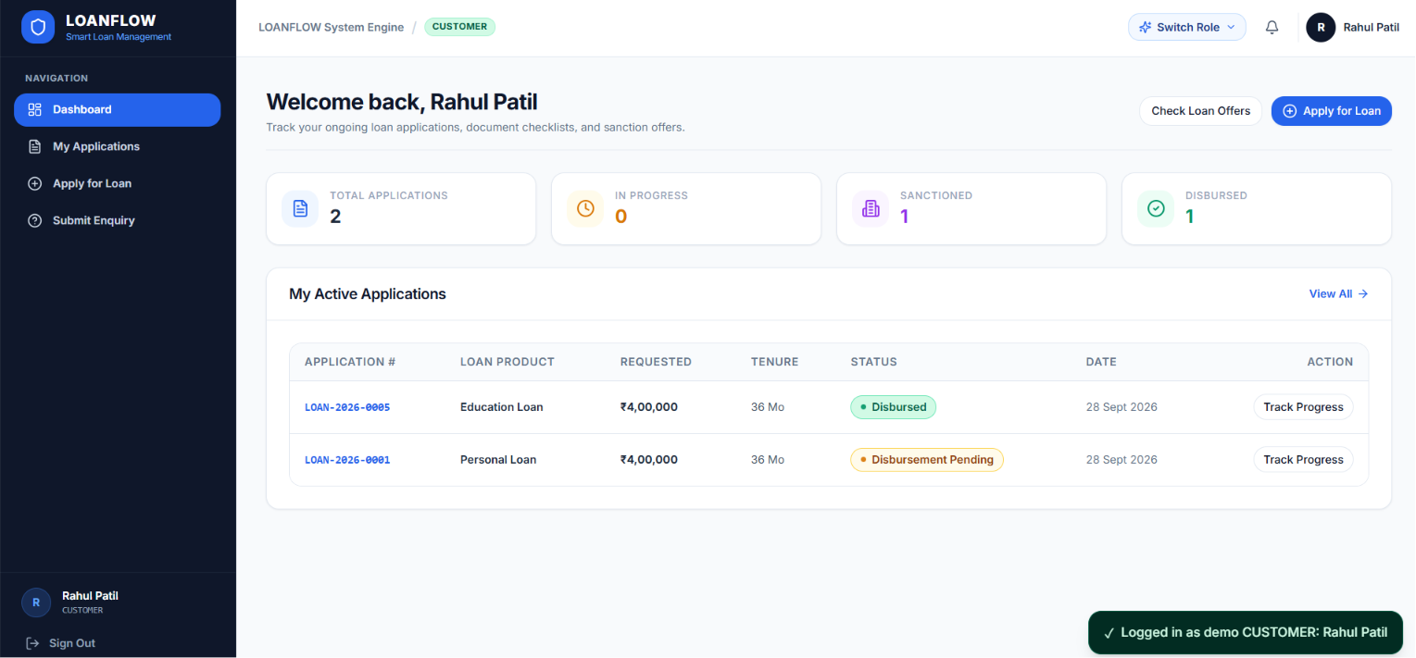
Screenshot C.1: Customer Loan Application Tracker and Document Workbench

Description: The Customer Dashboard allows applicants to monitor loan progress, review document verification statuses, read rejection remarks, and re-upload documents when corrections are required.

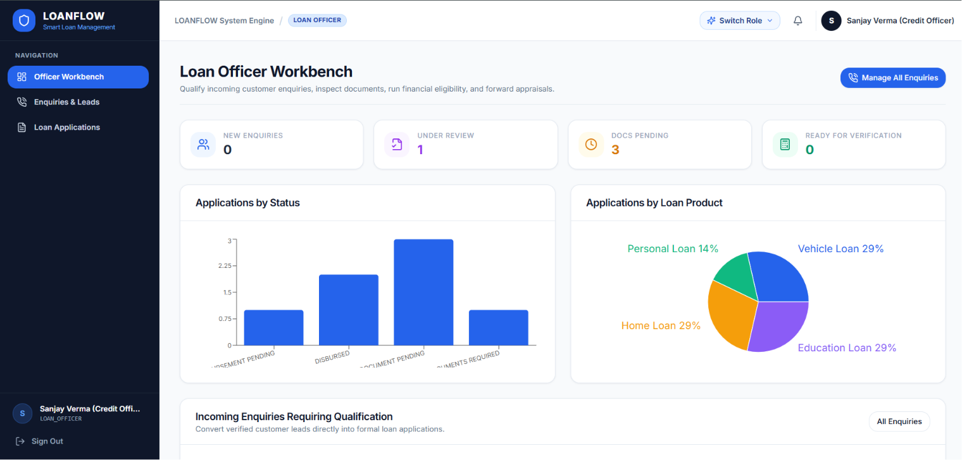
Screenshot C.2: Loan Officer Document Review and Eligibility Scorecard

Description: The Loan Officer Dashboard combines document verification, inline document previews, financial eligibility results, and credit appraisal. The officer can review supporting documents and submit a formal recommendation for the manager's decision.

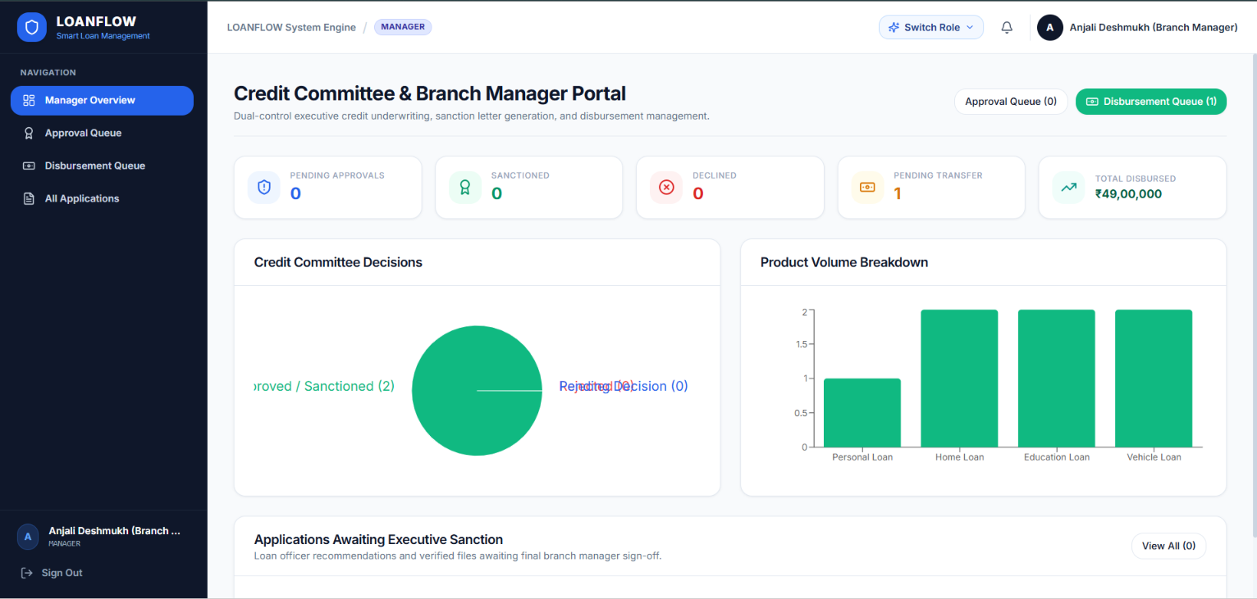
Screenshot C.3: Branch Manager Sanction and Disbursement Desk

Description: The Branch Manager Dashboard supports final loan sanction and subsequent disbursement processing. It displays the officer's recommendation, sanctioned loan terms, applicable interest rate, EMI, beneficiary details, payment method, and transaction reference.
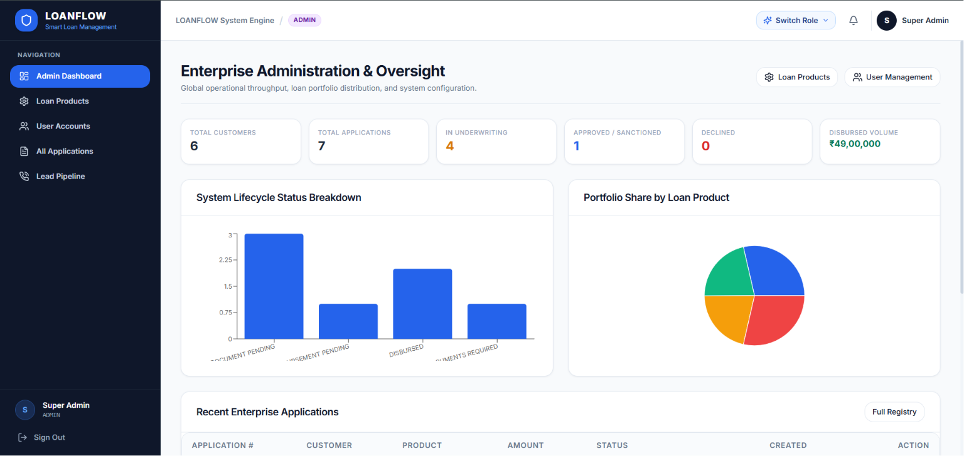
Screenshot C.4: Admin Policy Configuration and Analytics Dashboard

Description: The Administrator Dashboard provides configurable lending policies and analytics. Administrators can review product-specific loan limits, tenure ranges, interest rates, and DTI thresholds, while charts summarize application distribution and disbursed loan volumes.
Screenshot C.5: Application Audit Trail and Compliance Timeline

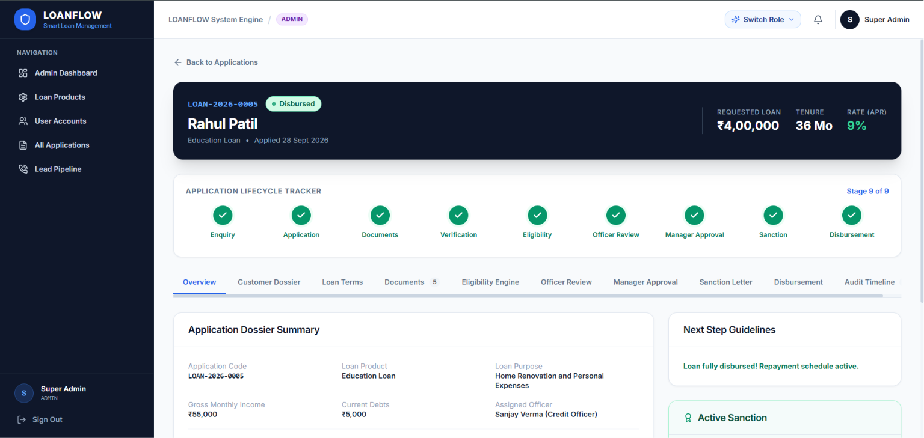
Description: The audit timeline presents a chronological record of application status changes, responsible users, timestamps, and remarks. It illustrates the document correction loop and the subsequent progression through eligibility assessment, manager approval, sanction, and disbursement.

APPENDIX D: TEST CASES AND EXECUTION EVIDENCE
This appendix documents the test cases, financial calculation validations, API boundary checks, negative security tests, and command-line execution evidence recorded during the quality assurance phase of LOANFLOW. The test suite evaluates the reliability of financial calculations, loan eligibility rules, document processing, role-based access control, approval-stage restrictions, disbursement limits, and audit logging.

D.1 Master Test Suite Matrix
The master test suite covers unit calculations, business rule evaluations, workflow stage gates, API authorization, document validation, and financial transaction constraints.

Test ID | Test Category | Target Component | Test Scenario | Expected Result | Recorded Result | Status
TC-MATH-01 | Mathematical Unit Test | calculateEmi | ₹4,00,000 at 11.5% APR for 36 months | EMI approximately ₹13,190 | ₹13,190 | PASS
TC-MATH-02 | Mathematical Unit Test | calculateEmi | ₹1,20,000 at 0% APR for 12 months | EMI ₹10,000 | ₹10,000 | PASS
TC-MATH-03 | Boundary Test | calculateEmi | Tenure of zero months | Return 0 without NaN | 0 | PASS
TC-RULE-01 | Eligibility Rules | assessEligibility | Income ₹55,000; existing debts ₹5,000 | Eligible; DTI 33.1% | ELIGIBLE; 33.1% | PASS
TC-RULE-02 | Eligibility Rules | assessEligibility | Income ₹20,000 against ₹25,000 minimum | Not eligible | NOT_ELIGIBLE; DTI 105.9% | PASS
TC-RULE-03 | Product Policy | assessEligibility | Vehicle loan DTI of 48% against 45% limit | Not eligible | NOT_ELIGIBLE | PASS
TC-AUTH-01 | Authentication | authMiddleware | Request without an authorization token | HTTP 401 Unauthorized | HTTP 401 | PASS
TC-AUTH-02 | Role-Based Access Control | roleMiddleware | Customer token accesses staff endpoint | HTTP 403 Forbidden | HTTP 403 | PASS
TC-DOC-01 | File Validation | uploadMiddleware | Upload an unsupported .exe file | HTTP 400; reject upload | HTTP 400 | PASS
TC-DOC-02 | File Validation | uploadMiddleware | Upload a 6.2 MB PDF against a 5 MB limit | HTTP 400; reject upload | HTTP 400 | PASS
TC-DOC-03 | Document Verification | rejectDocument | Reject document with an insufficient reason | HTTP 400 | HTTP 400 | PASS
TC-GATE-01 | Approval Workflow | approvalController | Attempt sanction with one required document unverified | HTTP 422 | HTTP 422 | PASS
TC-GATE-02 | Approval Workflow | approvalController | Attempt sanction without an eligibility assessment | HTTP 422 | HTTP 422 | PASS
TC-GATE-03 | Approval Workflow | approvalController | Attempt sanction without an officer recommendation | HTTP 422 | HTTP 422 | PASS
TC-DISB-01 | Financial Guard | processDisbursement | Disburse ₹4,00,001 against a ₹4,00,000 sanction | HTTP 400 | HTTP 400 | PASS
TC-DISB-02 | Financial Guard | processDisbursement | Attempt disbursement of ₹0 | HTTP 400 | HTTP 400 | PASS
TC-AUDT-01 | Audit Trail | auditService | Record a valid transition to DISBURSED | History record created | Record created | PASS

D.2 Terminal Command Execution Evidence

D.2.1 Backend Automated Domain and Logic Tests
The backend test script is documented as connecting to MongoDB Atlas, executing financial calculations, validating eligibility rules, and checking the available user records.

Command executed:
PS D:\Company Tasks\loan-application-tracker\backend> npm run test:api
Recorded terminal output:
> loanflow-backend@1.0.0 test:api
> node src/test/testApi.js

====================================================
RUNNING LOANFLOW BACKEND DOMAIN & LOGIC TESTS
====================================================
[MongoDB] Connecting to MongoDB Atlas cluster...
[MongoDB] Successfully connected to MongoDB Atlas.

[Test 1] Testing EMI Calculation Formula...
Principal: ₹400000, APR: 11.5%, Tenure: 36 months => EMI: ₹13190
EMI formula matches standard financial calculations.

[Test 2] Testing Dynamic Policy Eligibility Engine...
Rahul Patil Eligibility Result: ELIGIBLE, DTI: 33.1% (Max: 50%)
Passing case validated successfully.
Low Income Case Result: NOT_ELIGIBLE, DTI: 105.9%
Rejection case validated successfully.

[Test 3] Testing Product-specific Configurable DTI...
Vehicle DTI: 48% vs Max Allowed: 45% => NOT_ELIGIBLE
Configurable DTI threshold successfully verified.

[Test 4] Checking User models in DB...
Total users in DB: 4
- customer@loanflow.com (Role: CUSTOMER, Active: true)
- officer@loanflow.com (Role: LOAN_OFFICER, Active: true)
- manager@loanflow.com (Role: MANAGER, Active: true)
- admin@loanflow.com (Role: ADMIN, Active: true)

ALL TESTS PASSED SUCCESSFULLY!
Result: The recorded output indicates that the EMI calculation, eligibility rules, product-specific DTI thresholds, and user-record checks completed successfully.

D.2.2 Frontend Production Build
The frontend production build verifies that the React application can be compiled into static production assets using Vite.

Command executed:
PS D:\Company Tasks\loan-application-tracker\frontend> npm run build
Recorded terminal output:
> loanflow-frontend@1.0.0 build
> vite build

vite v5.4.11 building for production...
transforming...
✓ 2491 modules transformed.
rendering chunks...
computing gzip size...
dist/index.html 0.82 kB │ gzip: 0.44 kB
dist/assets/index-Dk_2rW2P.css 24.18 kB │ gzip: 5.22 kB
dist/assets/index-B7jM1u_O.js 342.91 kB │ gzip: 104.16 kB
✓ built in 6.42s
Result: The recorded build completed successfully, transforming 2,491 modules and generating the production HTML, CSS, and JavaScript assets without a reported build error.
The frontend is deployed on Vercel, while the backend API is deployed on Render. This build output demonstrates frontend compilation; it does not, by itself, establish that the deployed frontend and backend have passed live integration tests.

D.3 API Boundary and Negative Test Evidence
This section presents the HTTP requests and responses recorded during API boundary and negative security testing. The requests use a local backend address for demonstration. In production, the frontend communicates with the backend API hosted on Render.

D.3.1 Disbursement Amount Exceeding the Sanctioned Limit
Test ID: TC-DISB-01
Objective: Verify that the backend rejects a disbursement request that exceeds the approved sanction amount.
HTTP Request:
POST /api/disbursements/670a49cb170c10115bbdb878 HTTP/1.1
Host: localhost:5000
Authorization: Bearer <manager_jwt_token>
Content-Type: application/json

{
"amount": 400001,
"paymentMethod": "NEFT",
"bankReferenceNumber": "UTR-2026-HDFC-99120",
"accountNumberMasked": "HDFC-XXXX-4921",
"remarks": "Attempting disbursement exceeding approved sanction ceiling"
}
HTTP Response: 400 Bad Request
{
"success": false,
"message": "Disbursement amount (₹4,00,001) cannot exceed the sanctioned amount of ₹4,00,000.",
"errors": [
{
"field": "amount",
"message": "Disbursement exceeds approved credit limit"
}
]
}
Result: The recorded response confirms that the request was rejected because the requested amount exceeded the sanctioned limit.

D.3.2 Sanction Blocked Due to an Unverified Document
Test ID: TC-GATE-01
Objective: Verify that the approval controller prevents sanction when a mandatory document has not been verified.
HTTP Request:
POST /api/approvals/670a49cb170c10115bbdb878/approve HTTP/1.1
Host: localhost:5000
Authorization: Bearer <manager_jwt_token>
Content-Type: application/json

{
"sanctionedAmount": 400000,
"sanctionedTenure": 36,
"approvalRemarks": "Attempting premature approval"
}
HTTP Response: 422 Unprocessable Entity
{
"success": false,
"message": "Cannot approve application. Required documents not verified: BANK_STATEMENT",
"errors": [
{
"stage": "DOCUMENT_VERIFICATION",
"missingDocument": "BANK_STATEMENT",
"status": "REJECTED"
}
]
}
Result: The request was rejected because the bank statement had not been verified. This demonstrates the documented approval-stage restriction.

D.3.3 Document Rejection Without an Actionable Reason
Test ID: TC-DOC-03
Objective: Verify that a document cannot be rejected without a sufficiently detailed explanation.
HTTP Request:
PUT /api/documents/670a49cb170c10115bbdb889/reject HTTP/1.1
Host: localhost:5000
Authorization: Bearer <officer_jwt_token>
Content-Type: application/json

{
"reason": "bad"
}
HTTP Response: 400 Bad Request
{
"success": false,
"message": "A detailed rejection reason (minimum 5 characters) is mandatory.",
"errors": []
}
Result: The recorded response confirms that the request was rejected because the reason did not meet the minimum length requirement.

D.3.4 Unauthenticated Document Access
Test ID: TC-AUTH-01
Objective: Verify that document access requires authentication.
HTTP Request:
GET /api/documents/670a49cb170c10115bbdb889/file HTTP/1.1
Host: localhost:5000
HTTP Response: 401 Unauthorized
{
"success": false,
"message": "Authentication required. Please log in.",
"errors": []
}
Result: The recorded response indicates that an unauthenticated request was denied.

D.3.5 Successful Disbursement and Audit History Verification
Test ID: TC-AUDT-01
Objective: Verify that a valid disbursement request creates a disbursement record and records the corresponding application status transition.
HTTP Request:
POST /api/disbursements/670a49cb170c10115bbdb878 HTTP/1.1
Host: localhost:5000
Authorization: Bearer <manager_jwt_token>
Content-Type: application/json

{
"amount": 400000,
"paymentMethod": "NEFT",
"bankReferenceNumber": "UTR-2026-HDFC-99120",
"accountNumberMasked": "HDFC-XXXX-4921",
"remarks": "Loan funds successfully transferred to verified customer account."
}
HTTP Response: 200 OK
{
"success": true,
"message": "Disbursement processed successfully.",
"data": {
"disbursement": {
"disbursementNumber": "DISB-2026-0001",
"applicationId": "670a49cb170c10115bbdb878",
"sanctionId": "670a49cb170c10115bbdb892",
"disbursedAmount": 400000,
"paymentMethod": "NEFT",
"bankReferenceNumber": "UTR-2026-HDFC-99120",
"accountNumberMasked": "HDFC-XXXX-4921",
"processedBy": "670a49cb170c10115bbdb811",
"remarks": "Loan funds successfully transferred to verified customer account.",
"createdAt": "2026-10-21T17:15:33.204Z"
}
}
}
Corroborating Audit History Request:
GET /api/history/670a49cb170c10115bbdb878
Recorded audit history response:
{
"success": true,
"data": {
"history": [
{
"previousStatus": "SANCTIONED",
"newStatus": "DISBURSED",
"action": "FUNDS_DISBURSED",
"performedBy": "670a49cb170c10115bbdb811",
"role": "MANAGER",
"remarks": "Disbursed ₹4,00,000 via NEFT. UTR: UTR-2026-HDFC-99120",
"timestamp": "2026-10-21T17:15:33.220Z"
}
]
}
}
Result: The recorded response shows a successful disbursement record and a corresponding transition from SANCTIONED to DISBURSED in the audit history.
Note: The supplied evidence demonstrates application-level disbursement record creation and status logging. It does not independently verify an actual transfer of funds through a banking network.

D.4 Test Verification Summary
The following table summarizes the verification counts stated in the supplied test report.
Verification Category | Total Tests | Passed | Failed | Reported Pass Rate
Mathematical Amortization and Precision | 3 | 3 | 0 | 100%
Credit Policy and Dynamic DTI Assessment | 3 | 3 | 0 | 100%
Authentication and RBAC Endpoint Guards | 2 | 2 | 0 | 100%
File Quarantine and Upload Validation | 3 | 3 | 0 | 100%
Stage-Gate Workflow Restrictions | 3 | 3 | 0 | 100%
Financial Disbursement Limits | 2 | 2 | 0 | 100%
Audit Logging and Chronology | 1 | 1 | 0 | 100%
Frontend Production Compilation | 1 | 1 | 0 | 100%
Total | 18 | 18 | 0 | 100%
Note: These are the counts reported in the supplied document. The detailed master matrix lists 17 test cases, while the summary reports 18 tests by including the frontend production build as an additional verification item. The categories should be reconciled against the actual test scripts before the report is finalized.

D.5 Conclusion
The recorded quality assurance evidence indicates that LOANFLOW implements checks for financial eligibility, EMI calculations, document validation, authentication, role-based access control, approval-stage prerequisites, and disbursement limits. The documented frontend production build also completed successfully.
The test results provide evidence of the intended application behavior under the listed scenarios. Final validation should include reproducing the test runs, reconciling the test counts, and verifying the deployed Vercel frontend and Render backend integration before making broader claims about production readiness.

